August 2020 Newsletter
First Congregational United Church of Christ
1000 Willson Avenue - Webster City, Iowa 50595
515-832-2232
http://www.firstcongregationalwc.org/

“Therefore, my beloved, be steadfast, immovable, always abounding in the work of the Lord, knowing that your labor is not in vain in the Lord.” –1 Corinthians 15:58
When life hands you lemons, don’t give up—make lemonade! Even during a pandemic--even when the church building is shuttered to our normal activities! Since March 17th our church has resisted “giving up” and instead we are making do and making lemonade—trying new and creative ways to worship, continuing with our Board and Committee work, offering Christian education opportunities, raising funds, and engaging in service. Here is a partial recounting of the lemonade we have been making in the last month or so…
Worship: Our last congregational survey in June indicated that the majority of members who responded would be willing to try outdoor worship services in our vacant lot, and so we held our first corporate worship service since March 15 in our vacant lot on Sunday, July 5, beginning at 9:30 am. We used our ancient but still operational portable podium as our pulpit, and two sturdy souls carried out our electric piano to accompany us as we SANG together for the first time in nearly 4 months! We offered the sacrament of Holy Communion via single serve containers, each containing a piece of bread and a red grape for the elements. A wooden chest was brought out to accept our offerings, and bulletins and children’s treat bags were made available. Congregation members were required to mask and bring their own seating. Thirty-one members were in attendance that day! The following week we were able to borrow Chris McNiel’s new sound system, which greatly improved the quality of our sound! It takes many hands to bring out and put away all the equipment and materials needed for our outdoor worship services, but we have been blessed with many volunteers who have stepped up to help. As of this writing we have successfully concluded 4 weeks of outdoor worship and have only endured one small sprinkling of rain! It has been good to gather together to worship, and we will continue to improve the experience by adding a liturgist, a song leader, and special music to the services.
Meetings: We are improvising and conducting much of our business via email and phone calls, although some Boards have chosen to meet in person outside the building while safely social distancing. Our Stephen Ministers have met in our vacant lot, and both the Christian Education Board and the Mission Board have met there as well. The Worship Board has been very busy making decisions and organizing our outdoor worship services—all done by email. The Women’s Fellowship Executive Board concluded their program year with a meeting at Kendall Young Park, and the Finance Board and the Trustees continue their work by emailing. The Evangelism Board also confers via email and they sent out a letter of remembrance to all active members of our church. I applaud all the efforts to continue with our various responsibilities and ministries in these challenging times, and we are indeed finding that we can work together and remain effective even when our routines have been severely disrupted!
Education: We continue to remember our young people with monthly “we care” bags delivered to their doors, and beginning in September these bags will include a Sunday school lesson, a craft-- and treats, of course! During the summer we are conducting two book studies based on racism: a Zoom study of the book “White Fragility,” and beginning August 19th an in-person study of “Raising White Kids” at 7 pm in our vacant lot. Because of Covid-19 the Christian Ed Board has voted to not resume in-person Sunday School or KLAB for our kids this fall, so we will continue to look for alternate distance learning opportunities for all ages.
Fundraising and Service Projects: The Mission Board has been keeping us busy with opportunities to continue our Christian vocation of love and service! Early in July we delivered another carry-in meal to the Beacon of Hope-- provided by members who baked casseroles and donated sandwiches and bags of salads. All through July we have been collecting pancake mixes and syrup to take to the 2 Lutheran food pantries in town, and the response has been great! The Mission Board has encouraged support for the wider UCC national offerings “One Great Hour of Sharing” and “Strengthen the Church” throughout the month of July, and their big project was our recent “Brownie Sundae Drive-Thru” on July 24th, which raised over $2,000 in less than 2 hours’ time! This gift was matched dollar for dollar by a grant from Enhance Hamilton County Foundation and the money will be distributed to all 6 of our county food pantries. Church members have also been busy volunteering their sewing skills and have made masks for church members, for VDMC, and more recently, masks and gowns for the nursing staff of Good Samaritan Nursing Home in Davenport, Iowa.
As you can see, we are adapting, improvising and overcoming the challenges of these unprecedented times in order to continue our labors as a church. As this pandemic trudges on we will need to be steadfast in our resolve, immovable in our sense of hope, and faithful in our works and witness so that we remain strong and viable; abounding in love, in care, and in high purpose! This we can do…and every member of our church has a part to play in our labors! I urge everyone to continue to pray for one another and for our church, and I ask every member to prayerfully seek ways to continue our collective labors as a church while we are in physical exile from our church building and our pre-pandemic church routines. May God continue to bless us abundantly with insight, enthusiasm, and generous hearts as we continue to serve the Living God and all of our neighbors here-- and around the world! –Pastor Craig

CHURCH OFFICE HOURS

M 8 am - 11 am

Th 12:30 pm to 2:30

Church Staff

Rev. Craig Blaufuss, Pastor
Office: 832-2232 Cell 297-4316
Pastor’s email: revcraigblaufuss@wmtel.net
Michele Omvig: Admin. Assist. 269-7210
Church’s e-mail: administrative.office@fcuccwc.org
Dale Olson: Stephen Ministry Ldr 839-5619
Sunshine Garth: Choir Director 835-7626
Melissa Hindt: Organist 712-351-1074
Curt/Lorraine McCoskey: Cust’s. 832-5341
Tracy Wehrhan: Church Treasurer 297-0370
Dale Olson: Financial Secretary 839-5619

HAPPY BIRTHDAY TO:
1 – Madison Babington
2 - Bruce Perry
5 - Patty Gescheidler
7 - Richard Tudor II
12 - Jan Maxon
12 - Howard Stearns
15 - Audrey Burtnett
15 - Laurie Epps
16 - Tom Riemenschneider
18 - Debbie Jaycox
19 - Allison Yungclas
19 - Mary Van Diest
20 - Chad Elkin
21 - Mark Carlson
21 - Mary Worthington
24 - Nick Oberender
27 - Shari Rothrock
31 - Betty Ploeger
31 - Margy Wood

HAPPY ANNIVERSARY TO:
11 - Luverne & Verna Bierle
11 - Mark & Jennie Brim
23 - Don & Gretchen Bruner
31 - Jason & Amanda (Maass) Strahl

Scholarships
Scholarships will be awarded on Sunday, August 9 during the 9:30 a.m. worship.
Recipients are:
Hannah Stirling
Jackson Leman
Allison Arkland
Riley Nelson
Lauren Leman
Alexis Tudor
Control - your- stress checklist
- Are you often late? Take a look at your time management. Make it a habit to plan your day task by task (in advance), and give yourself enough time for your to-dos.
- Are you overextended? Determine what's truly essential and important and what you can put on hold or eliminate.
- Are you easily angered or irritated by anyone or anything? Pause to ask yourself if you are making something a bigger issue than it is or leaping to conclusions.
- Are you feeling pessimistic in general? Stop and remember all the things you have to be grateful for and vow not to compare yourself to others.
- Are you burned out? Consider self-nurturing activities to recharge and/or find help so you don't have to do tasks alone.

Relay for Life
This event was cancelled for this year, however, we would like to raise funds for the American Society. The pickle jar will be out during worship in August.

Book Study on Racism—Raising White Kids
We will begin the book study of "Raising White Kids" by Jennifer Harvey on Wednesday, August 19th, beginning at 7 pm. We want to try meeting in person to discuss this book, so our inaugural meeting will be held in our vacant lot. It is not too late to join this study! For more information please speak with Pastor Craig.

Sweeter Than a Brownie Sundae
What could top a lovely evening, brownie sundaes and dozens of carloads of friends stopping by? How about $2,058 in the free-will donation Pickle Jar? On Friday, July 24, our church held its first-ever drive-thru event – and it was a huge success. We lost count of the cars and pick-ups that lined up in front of the church to get a decadent dessert. Wonderful support from the community and the congregation means a large check will be presented to Enhance Hamilton County Foundation for its match to benefit the local food pantries. Who knew that helping to feed hungry neighbors could be so much fun? Thank you! – The Mission Board
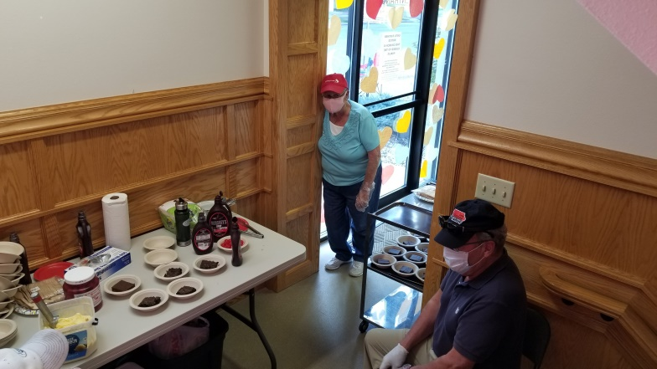
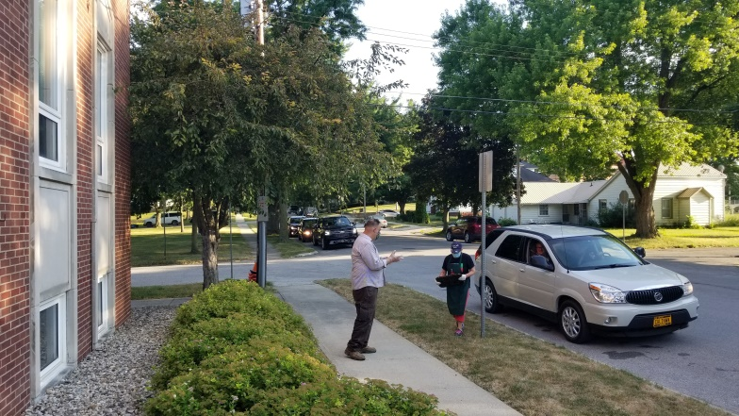
Sunday outdoor worship takes many hands to make ready! Many thanks to Chris-- and granddaughter Isabelle--McNiel for setting up and operating the sound system they are graciously allowing us to borrow. And many thanks to Melissa Hindt, who is gracing our service with her musical gifts!
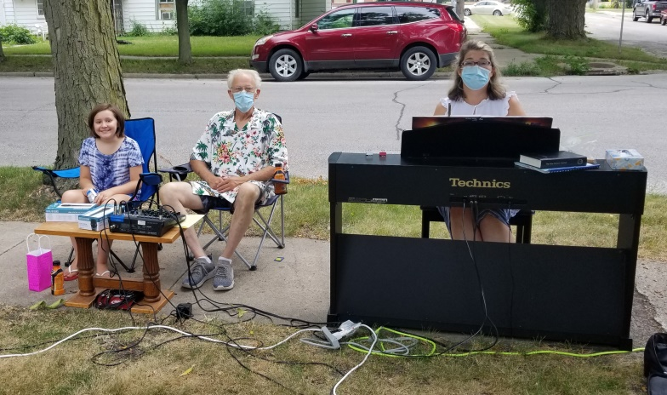

The West entrance is looking very different these days! The big "Thank You!" goes out to members of the Worship Board and other church members who have volunteered to help set up and tear down for our weekly outdoor worship services!
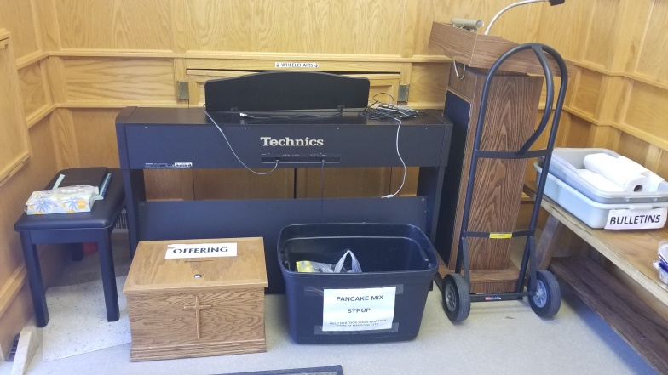

Thanks
Vicki and I want to thank Donna Ryherd, Carol Crystal and Mary Vavroch for their generosity and their gracious sharing of their time and sewing skills! These ladies sewed and donated masks to the Good Samaritan Care Center of Davenport where our granddaughter is the Director of Nursing. In addition, Donna sewed protective gowns for the nursing staff to wear. Good Samaritan was in great need of additional masks and gowns, and these ladies stepped up to help! Thank you! --Craig and Vicki

In early July the Mission Board put out a plea for donations of pancake mix and syrup, to be donated to the two Lutheran church pantries in town. You responded! Thanks to your generosity we will donate 20 bottles of syrup and 27 boxes of pancake mix!
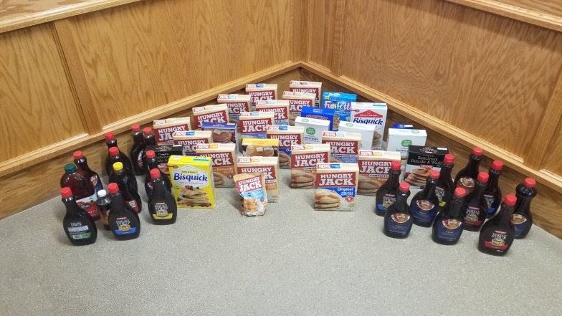

Treasurer’s Report
INCOME June YEAR TO DATE
Pledges and Offerings $10,467.46 $82,068.18
Other Income 0.00 .00
TOTAL INCOME $10,467.46 $82,068.18
EXPENSES
Outreach and Mission 0.00 $3,166.60
Pastoral Services 8,005.80 47,362.53
Maintenance and Repairs 2,296.00 14,809.79
Church Office 2,205.50 16,138.23
Music Ministry 336.00 4,925.75
Christian Education 0.00 0.00
Local Ministry 0.00 0.00
Misc. Expenses 6.42 949.66
TOTAL EXPENSES $12,849.72 $87,352.56

FIRST CONGREGATIONAL UNITED CHURCH OF CHRIST
Webster City, Iowa
Cabinet Minutes
Christian Education Minutes from July 22, 2020 at 5PM
All members were present in the lot next to the church: Pastor Craig Blaufuss, Wil Groves, Vicki Blaufuss, Karinne Tudor, Laurie Epps and Jane Klaver.
Pastor Craig lead us in an opening prayer with Wil Groves directing the meeting. Minutes were summarized by the secretary with Vicki moving to approve them, a second by Jane, and an approval by all attending. Many activities were not completed as planned at that March meeting due to the closedown on March 17 due to the pandemic. KLAB did go to Fort Dodge on March 11 to deliver towels, blankets and the $543 check.
Old business consisted of a discussion of “We Care” packages distributed to each student’s house by Vicki and Craig during the last 4 months. Vicki gave us an update on the packages. On Palm Sunday 20 bags were filled with Easter objects and candy. In May KLAB helpers and students were recognized with a certificate and a Dairy Queen card. Notes were included from board members in June with candy and juice boxes. Again, in July there were personal notes along with popular figurines for younger kids and pens/pencils for the older ones.
We will be writing personal notes, 5 each board member, to be turned in by July 29. These August “We Care” bags will also include items from the school supply list. We have plans to continue this activity to keep in touch with our youth through December since in these Pandemic times it is hard to make any further plans. We will revisit this decision if things change.
Pastor Craig gave us an update on pandemic church policy. Church members are not to gather inside the church. Services will continue outside the church until weather makes us rethink and search for another alternative. Individual members may enter the church for a specific purpose but KLAB or services will not be held until there is perhaps a vaccine.
Some different thoughts about activities for KLAB were discussed. Perhaps a competition might be held among students with a self-addressed envelope for the church in each package or the possibility of a picture taken by a family member as proof of completion. We will continue with the monthly “We Care” packages, including, perhaps, a craft. Wil, Vicki and Karinne will evaluate the craft boxes in the church and restock them so that they might be sent home to use on the craft/activity. Students would have all supplies provided to complete the craft at home. Laurie will look at some distance learning activities and crafts.
The Living Nativity might be a possible activity again this year with no cocoa and cookies inside the church.
Meeting adjourned. Respectfully, Jane Klaver, Secretary

Trustees
Trustees would like to thank Chris McNiel for putting in an electrical plug on the south side of the church. This is very helpful for our outside Sunday services.
The creeping charlie on the lots is being treated by our lawn service with every application.
Pastor Craig will be looking at pricing for updating computers for him and the church office.
Joyce Gelhaus

Mission Board Minutes July 16, 2020, 10 a.m.
Church vacant lot: Rev. Craig Blaufuss, Audrey Burtnett, Marjorie Groves, Lorraine McCoskey, Gayle Olson, Karin Yungclas. Audrey led us in prayer.
T-Shirt Totes for Food Bank of Iowa: This project worked well for quarantined coronavirus times. We will revisit the topic at a future meeting and likely will start it again as an ongoing project.
Food Pantries: So far, our pancake mix and syrup collection for the St. Paul and Trinity Lutheran food pantries has filled a tote and a half. We will continue the opportunity to give these food products through July.
One Great Hour of Sharing and Strengthen the Church: As of Sunday, July 12, $360 had been given for OGHS and $160 for STC. We will collect for both special offerings throughout July.
Beacon of Hope: Pastor Craig reported that the Fort Dodge shelter was happy to get our church’s July 7 meal. Volunteers were slower to offer casserole, salad and bar donations this time, as compared with the May meal. September is next for our church to provide the meal.
Relay for Life: Gayle will ask Joyce Gelhaus, our First Congregational UCC team captain, if she wants to write a promo for a Pickle Jar collection throughout August. The American Cancer Society event is cancelled for this year, as have our church’s coffee times where Mission Board has raised money in the past.
Book Study: Discussion of White Fragility started July 14 with 6 in the daytime group and 6 in the evening group Zoom discussions. Pastor Craig says the Raising White Kids discussion might be done face to face outside because a small number have signed up.
Ice Cream Social: July 24, 6:30-8 p.m., for the first-ever Brownie Sundae Friday. In case of rain, July 31. Gayle has purchased six gallons of ice cream. Pastor Craig will buy one more, along with another bottle of chocolate sauce. Audrey and Lorraine also will buy chocolate sauce to supplement the two Gayle has obtained. Craig will check our church paper napkin supply. Drive-thru options are (1) brownie, ice cream and chocolate sauce; or (2) ice cream and chocolate sauce. There will be no other options offered. Marjorie and Wil Groves will prepare press releases for The Daily Freeman Journal, KQWC and Facebook. We will not buy ads or commercials. Karin will contact the Webster City Community Theatre about announcing the Brownie Sundae Friday on the WCCT electronic sign. Karin will make posters for the two community billboards. Lorraine will make a sign for her yard; Marjorie will contact Gretchen McGlynn to see if we can put a sign in her yard. Gayle will make directional signs and arrows from Superior Street to the drive-thru on Willson. Workers: Audrey approaches cars with Pickle Jar for donations; Karin cuts brownies and puts in bowls; Lorraine and Curt scoop ice cream and apply chocolate sauce; Gayle, Dale, Marjorie and Wil take orders, relay orders and deliver orders; Pastor Craig is a swing worker if needed and blesses the food. All workers remain masked and gloved throughout the Brownie Sundae Friday. Workers will gather at the church at 6 p.m. to start plating and strategizing. Craig will notify police in case serving causes a traffic slow-down in front of the church.
Open and Affirming: We will talk about this topic at Mission Board meetings and in formal and informal discussions with the congregation. Advice on the process is on the UCC website: openandaffirming.org/ona/how/guide
Next Meeting: Wednesday, August 19, 10 a.m.
Respectfully submitted, Marjorie Groves, Secretary

First Congregational United Church of Christ
1000 Willson Avenue
Webster City, IA 50595

Address Service Requested

God is still speaking
to everyone in the home of:

