**January 2025 Newsletter**

**First Congregational United Church of Christ**

**1000 Willson Avenue - Webster City, Iowa 50595**

**515-832-2232**

[**http://www.firstcongregationalwc.org/**](http://www.firstcongregationalwc.org/)

*“You will keep in perfect peace those whose minds are steadfast, because they trust in You”*

*–Isaiah 26:3*

We again held our Living Nativity on Saturday December 7, and for me it was an opportunity to “step into” the ancient and well-loved tableau that is central to our faith. To stand or kneel while reenacting the Nativity is a kind of spiritual practice for me, and in the half-hour I portrayed Joseph, I felt the peace and beauty of the Holy Night we were trying to recreate…until a freight train rolled into town.

As the train came, it blew its horn—not once, but again and again, and it was LOUD. It was REALLY LOUD…and as the train passed through town you could hear the train track making its rhythmic clickity-clacking noise, which for some reason also seemed ridiculously LOUD. I tried to shut the noise out and remain centered and at peace, but I couldn’t do it. And suddenly the peace, the beauty, the goodwill; everything I had been feeling which was so Christmassy and beautiful…was gone. I felt like the Grinch from the cartoon—reeling from all the Noise! Noise! Noise! drowning out the beauty; drowning out the peace; drowning out the joy.

And then, when that train departed another train came through barely 5 minutes later! It too had to continually blow its LOUD horn, and the clickity-clack of the track made a staccato mockery of what we were trying to offer to the public…and it again shattered the peace I had been experiencing on that silent, holy night.

I was actually mad that my peace was shattered by the coming of those trains! But then I realized something: Jesus wasn’t born in the midst of a great peace of some beautiful vignette. He was born in a cattle stall in the midst of all the crowds gathered in Bethlehem! There were animals making noise…people on the street coming and going with shouts and cursing and pleas…there were the screams of a too-young mother giving birth…there was the pandemonium that inevitably comes whenever one is born in this world. Baby Jesus was born into a time when censuses were taken, people were taxed, Roman legionnaires marched, merchants hawked wares, high priests sacrificed

screeching animals, carpenters pounded wood, and young women noisily gave birth-- sometimes living, sometimes dying in the process. There was precious little peace at his coming; for that matter there was precious little peace to later accompany him all along his short life. Whatever moments of peace I felt during our Living Nativity, and whatever moments of peace were felt at the first Nativity by a mother and a father and a baby lying in straw in the midst of squalor…that peace was precious, but it was not to be his lot. He would need to grow beyond any snatches of peace experienced at his Nativity; he would need to find the peace that passes all human understanding: a peace that would carry him through this world with all its noises and disturbances.

Jesus found that peace…in his undying connection to the Father. That connection, that unity of heart, mind, soul, and purpose, is what carried Jesus along and sustained him so that he could keep his peace in the midst of all of life’s chaos and upheaval. And he came to show us that we too can share in that connection and that peace as well…if we will ground our peace in God, rather than the externals of our noisy and disturbing world. And how beautiful to think that the peace I experienced all too briefly during our Living Nativity can remain with me even when the trains come; even when the storms of life come. I can hold onto such peace…if I will only hold onto God as my peace, as

Jesus did.

Friends, a New Year is again upon us, and I am greeting 2025 with a mix of hope and dread. The world is a million miles away from creating any real peace—either in her affairs, or in the hearts and minds of her inhabitants. This means that the world will not do our work for us of creating peace on earth, or peace within ourselves. In the words of “Sweet Little Jesus Boy”: That’s how things are done down here. This isn’t heaven, or the Kingdom of Heaven!

But our Good News is that we have One who came to us from Heaven, and he brought his peace to show us, and to share with us—if we will join him in sharing God as our peace. If we will do that, then 2025 will be a great blessing to experience—and a great opportunity to continue Jesus’ work of sharing peace with the weary souls of this weary world. That work is sorely needed! And as Jesus noted, “blessed are the Peacemakers, for they will be called the children of God.” That was one role Jesus never outgrew, and that was his peace. It can be ours as well!

Happy New Year! Happy Peace! –Pastor Craig

**Church Staff**

**Rev. Craig Blaufuss,** Pastor

Office: **832-2232** Cell **297-4316**

Pastor’s email: **revcraigblaufuss@gmail.com**

**Michele Omvig:** Admin. Assist. **269-7210**

Church’s e-mail**:** [**administrative.office@fcuccwc.org**](mailto:administrative.office@fcuccwc.org)

**Melissa Hindt:** Organist **712-351-1074**

**Curt/Lorraine McCoskey:** Cust’s. **832-5341**

**Tracy Wehrhan:** Church Treasurer **297-0370**

**Dale Olson:** Financial Secretary **839-5619**

**CHURCH OFFICE HOURS**

M 8 am - 1 pm

T 9 am – 1 pm

W 8 am – 4:30 pm

Th 8 am – 4:30 pm

F 9 am – 1 pm

**HAPPY BIRTHDAY TO:**

3 - Alec Tudor

6 - Kayleigh MacRunnel

7 - Kallista Gilbert

10 - Peyton Oberender

10 - Brynley Weig

13 - Jennifer Gilbert

14 - Marjorie Groves

14 - Travis Wearda

28 - Jennifer Brim

30 - Jenny Maass

31 - Kolleen Taylor

**HAPPY ANNIVERSARY TO:**

1 - Lynn & Sherry Leksell

4 - Don & Gene Royster

12 - Keith & Dawn Holdgrafer

17 - Wil & Marjorie Groves

**Parish Nurse News**

How to more effectively cope with an Anxiety Disorder -

* Avoid alcohol and recreational drugs
* Eat healthy food
* Identify triggers
* Keep physically active
* Learn about your disorder
* Make sleep a priority
* Quit smoking and reduce or quit caffeinated beverages
* Socialize
* Stick to your treatment plan
* Use stress management and relaxation techniques
* Write in a journal

**Annual Meeting**

The Annual Meeting will be Sunday, January 26 after worship.  Many important topics will be discussed at this meeting so knowing there will be a variety of soups to enjoy after will help keep you going!  Mission will be providing and serving the soup and putting out the pickle jar for donations that will go to a food pantry or 2 here in WC.   
So please mark your calendar for the 26th for an important annual meeting and then staying to enjoy some delicious soup after.

**Building Fund**

The Trustee and Finance boards would like everyone to consider donating to the building fund to help offset expenses that will occur in 2025 for repairs to the church building. This could also help with your income taxes for the year. Please write "building fund" on the memo line of your check.

**Church Officers**

We have several boards and committees to ensure smooth operation of the church which need new members. Please consider joining a board for 2025. Most boards have a two-year term and you can serve two consecutive terms. You can be on more than one board. There is a sign-up sheet in Fellowship Hall, please consider signing up. We need YOU!

**Auction**

Mission Board would like to thank all the donors of crafts, baskets and edibles for making the auction possible.  We would also like to thank all those that bid on these items creating an event that was both fun and profitable. And thanks, Curt, for your auctioneering skill.  The total raised was $2,425.00 which will all go toward fixing the bell tower. THANK YOU ALL FOR YOUR GENEROSITY!!

**After Christmas**

The “undecorating” of the church will take place after worship on Sunday, January 5th.  “Many hands make light work.”  Coffee, juice, and cookies will be served after we are finished. Hope you can help!

The Worship Board

**OH, NUTS!**There are not many bags of pecans left, they are now being stored in the chest freezer. If you're paying with a check, please make it out to Haystack Circle and leave it with Michele in the church office. Enjoy!

**Find Your Niche** Please prayerfully consider making a one-year commitment to help smooth the transition from pastor Craig’s retirement in March 2026 to the next phase of our church life together. A poster and sign-up sheet is now available. Meanwhile, please be thinking of how you will help keep First Congregational continuing its 169-year history of faith, love, and service!

**Thanks**

Words cannot express how grateful I am for all your cards and gifts and visits and prayers especially during this Christmas season. I have been thinking of my church family all season long, and I am keeping all of you in prayer for the new year! With my love, Audrey

Thank you for the thoughts and prayers for us when Larry had by-pass surgery. Thank you, also, for all the birthday greetings he received when he was in the hospital. It was all very kind. Thanks also to Haystack Circle for the Christmas treats. Blessings to you for a happy and healthy 2025.

Larry and Elaine Brim

**Task Force Report**

Please review this update from the task force, a summary of our findings so far. We’ll use it as a discussion starter at the annual meeting. No decisions will be made then; that will come sometime later by congregational vote. Now we seek a sense of direction from members about which pastoral leadership option to pursue as we move forward. This update is also included in the 2024 annual report. We urge everyone to attend the annual meeting, January 21. We need your input. Meanwhile, please feel free to contact task force members with comments, questions, and concerns.

The church cabinet established a task force earlier this year at its February meeting. Its purpose is to explore pastoral leadership alternatives following pastor Craig’s retirement in March, 2026. Members include: Wil Groves, past moderator; Gayle Olson, current moderator; Curt McCoskey, incoming moderator; Patty Gescheidler, Women’s Fellowship chair: Tracy Wehrhan, church treasurer; Chris McNeil, board of trustees member; Kolleen Taylor, church clerk; and Pastor Craig. That process has involved much discussion and thoughtful consideration as we continue to gather information and insights. We will bring what we have learned to the membership in the coming months to discuss and discern our path to the future. We welcome your questions, comments, and discussion as we move forward.

The task force has focused on these concerns: Pastoral leadership, membership, building maintenance, and finances. Here’s a summary of our work so far:

1. Members want to continue the 170-year ministry of First Congregational. We are studying several options for pastoral leadership: full time; part time; short term intentional interim; sharing a pastor with one or more other churches; and finally, as a lay-led congregation without professional pastoral leadership. Each has advantages and drawbacks. We are thoroughly investigating each option. We recently met with UCC Conference minister Kendy Miller and representatives of other area UCC churches with the same concerns about the future we have. We will have another meeting with Kendy soon to continue discussion and look for ways we might cooperate together.
2. We plan to continue to use our current church facility for at least the next 5-10 years. So, we are trying to project building maintenance and upkeep needs for that timeframe. Judicious use of building funds is a must. We applied for a grant that would have helped with bell tower restoration costs but we did not quite fit the grant criteria. We continue to work closely with trustees and finance board as they pursue a course of action on the bell tower, which seems to be the most urgent need in the next 5 years. Ultimately, the bell tower and the pastoral leadership decisions will rest with the congregation.
3. Assuming current trends continue, we expect membership, and therefore financial support, to decline as current members “age out.” That is important as we look to fill our pastoral leadership roles and wrestle with the church building maintenance and upkeep issues. We created and sent a survey to update our membership rolls and indicate who is committed to joining us on this next stage in our church life together. We also created a list of pastor/lay-led duties now being performed by Craig and others. General categories are administration; pastoral care/lay leadership/spiritual; technical; and creative. From this master list, we pulled our “must haves”—those pastoral services that must continue if we are to fulfill our Christian mission, regardless of the form of pastoral leadership we ultimately choose to pursue. Then we added our “wants”—services that would continue as part of our mission if someone is willing to head them. We combined the two into a “Find Your Niche” list, which challenges members to make a one-year commitment to fill important leadership roles when Craig retires. Response has been gratifying. Please check the service opportunities that still await to see if some align with your interests and gifts for ministry.

We are fortunate to have two years to prepare for the next phase of our journey together as a church family. We are fortunate to have had pastor Craig’s ministry of care and love the past 14 years. We are thankful that he’ll help us discern our direction during the final year of his tenure. There will be challenges. The coming years will test our spirit and our resolve.

Task force members are committed to keeping our church, our members, and our ministries alive and aligned with the “new thing” (Isaiah 43:19) that God is even now doing in our midst, in our community, and in our world. We prayerfully ask for everyone’s continued commitment and resolve as we move forward into the new future we are shaping together as a church, with God’s help.

**Our KLAB kids finished out the year making more Christmas crafts, and ended by unwrapping a cellophane party ball! Thanks to Gretchen McGlynn for donating the ball! The kids loved it!**

**December 15 was our Christmas luncheon and auction! It was a great meal and great fun for a good cause. All moneys raised went toward bell tower renovations.** 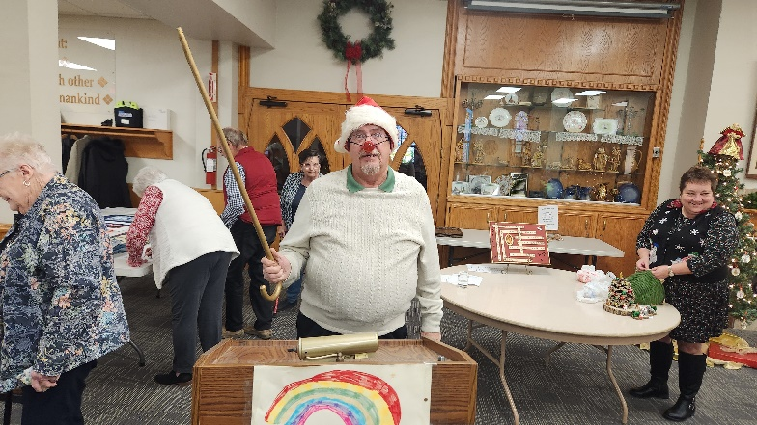

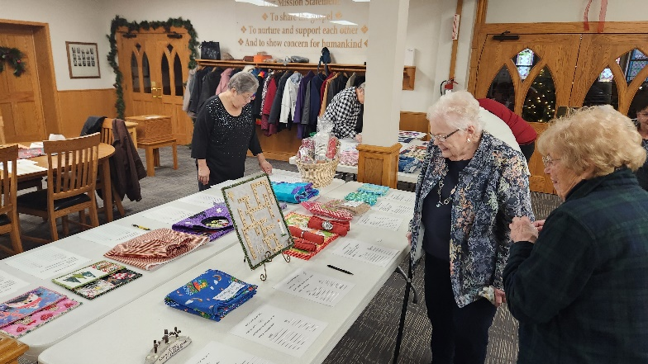

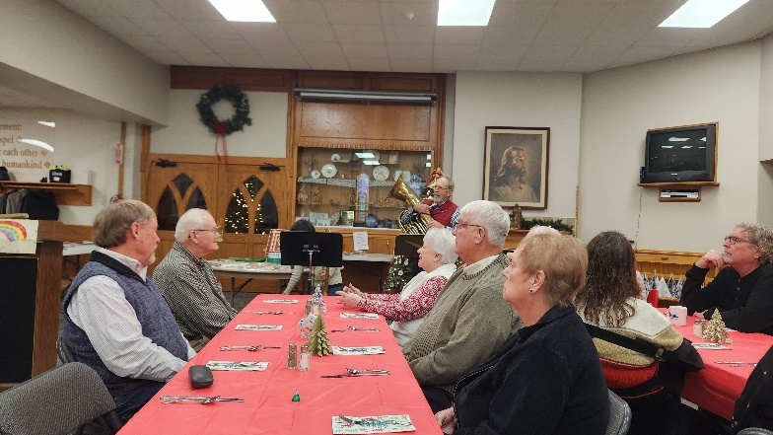

**December 7 was our Living Nativity, part of a citywide Christmas celebration!** 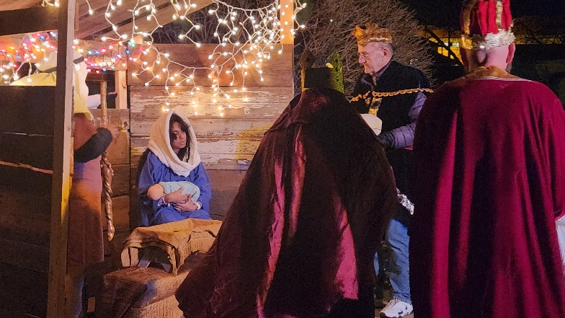

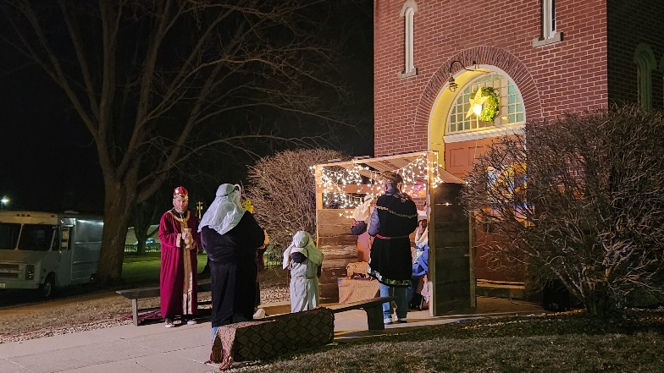

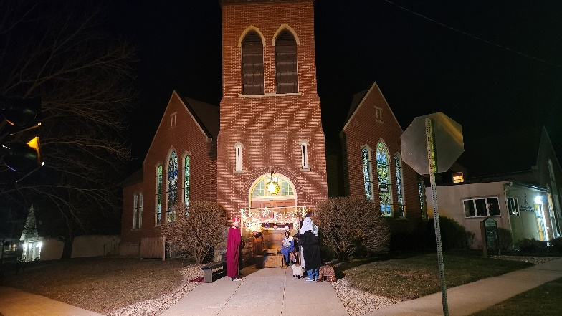

**Treasurer’s Report**

**INCOME November YEAR TO DATE**

Pledges and Offerings $14,395.00 $203,409.40

Other Income 0.00 .00

**TOTAL INCOME $14,395.00 $203,409.40**

**EXPENSES**

Outreach and Mission 1,250.00 $13,750.00

Pastoral Services 8,545.86 91,438.66

Maintenance and Repairs 1,098.53 35,792.42

Church Office 2,947.02 37,590.71

Music Ministry 492.25 5,639.75

Christian Education 53.70 263.05

Local Ministry 0.00 0.00

Misc. Expenses 6.42 2,447.63

**TOTAL EXPENSES $14,393.78 $186,922.22**

**First Congregational United Church of Christ**

**December 3 Cabinet Meeting**

ATTENDANCE: Moderator Gayle Olson, Vice Moderator: Curt McCoskey, Treasurer: Tracy Wehrhan, Financial Secretary: Dale Olson, Clerk: Kolleen Taylor, Trustees: Laurie Epps, Women’s Fellowship: Patty Gescheidler, Christian Education: Cindy Henning, Staff/Parish Relations: Carol Crystal. Mission: Stephanie Hill, Pastor Craig Blaufuss

The moderator Gayle Olson opened the meeting at 7:34 p.m. Pastor Craig offered a brief prayer.

*Minutes*: Wehrhan made a motion to approve the minutes as written, seconded by Henning.

**Financial Report:** Wehrhan reported that everything is on target. Income is currently above expenses for the first time in many years. He made a motion to accept the report for audit, seconded by D. Olson.

**Pastor’s report**

All Saints Sunday held on November 3 and Hanging of the Greens was November 24. Advent began on December 1. December 24 will be Christmas Eve service at 5 p.m. December 29 will be led by the Worship Board with a video sermon. Several different pianists will be substituting for our organist Melissa Hindt in December. We led Care Center services November 10, and led Gospel Hour at Southfield on Nov. 6 and on Dec. 4. The Blue Christmas Service at Faith UMC was better attended than last year, and Pastor Craig assisted with that special service. Kayla Nelson Blackburn will have her daughter Jessica baptized on Sunday, Dec. 22 during worship. Bell ringing for Ecumenical Human Needs will be done on Friday December 5. Shalom Circle continues to meet at 6:30 pm most Fridays.

Associate Conference Minister meeting held on November 11 had representatives from four churches to discuss future leadership options. The churches in Fort Dodge, Eagle Grove and Blairsburg are without pastors currently. Another joint meeting will be held in January

Tri-Conference Meeting: On Dec. 2 they elected a new Executive Conference Minister, Rev. Roberto Ochoa. He is originally from East Los Angeles, CA. He will start his new position in January.

Since October 8, Pastor Craig led 14 worship services, 15 Christian Education sessions, attended 12 meetings, and visited 12.

**Finance:** Did not meet

**Trustees:** Laurie Epps reported that Trustees should look at more tuck-pointing of bricks at West Entrance. She also talked about the sidewalk repairs needed by the west entrance, in addition to the bell tower estimates. After comparing quotes from RMH Architects, and Tomitech Engineering, the Tomitech quote was half the price for the same work. It was discussed that the members of the church should be included in the decision about what should be done at the Annual Meeting in January.

**Mission**: Met November 6, Alternative Giving fair auction is ready, with Curt McCoskey as auctioneer. The proceeds from this will be used for the bell tower expenses.

**Women’s Fellowship:** The annual Christmas dinner will be held on December 15. They are also reviewing the funeral policy.

**Worship:** Provided luncheon for the hanging of the greens, but has not met since.

**Christian Education:** KLAB: Raising money for The Cat Hut, delivered after holidays. No KLAB on December 24 & 31. Jan 7, 2025 Klab will resume. Snacks always appreciated!

Adult Education: There will be class on December 22, 2024, no class on December 29.

Dawn & Patty go off Christian Education Board and need two replacements

The Safe Church Policy is being reviewed and will have a training session for Klab helpers in the future.

**Staff/Parish relations:** No report

**Old Business:**

**Safe Church policy**: G. Olson reviewed the changes to the Safe Church policy. A motion was made by Henning to approve, McCoskey seconded, all approved.

**Church membership list:** A letter requesting reinstatement to active membership was received from Sue Jaycox. Taylor made a motion to reinstate Sue Jaycox, seconded by Henning. All approved.

Epps made a motion to remove the member names by request, Crystal seconded all approved.

McCoskey made a motion to remove the names of members who had not responded to letters, nor involved on any level, seconded by Wehrhan, A vote of eight to approve the motion, two opposed. Motion passed.

**New Business:**

Annual meeting date: Set for January 26, 2025.

Annual reports due on December 14, 2024

Discussion on the future after Pastor Craig retires, included three options that need discussed with membership. It was suggested that Wil Groves give a presentation at the Annual Meeting.

The next cabinet meeting will be on January 14, 2025. The meeting adjourned at 8:46 pm

Respectfully submitted, Kolleen Taylor, Church clerk

FIRST CONGREGATIONAL UNITED CHURCH OF CHRIST

**Address Service Requested**

God is still speaking

to everyone in the home of:

