**February 2025 Newsletter**

**First Congregational United Church of Christ**

**1000 Willson Avenue - Webster City, Iowa 50595**

**515-832-2232**

[**http://www.firstcongregationalwc.org/**](http://www.firstcongregationalwc.org/)

*“Who do you say that I am?”* –Matthew 16:15

I want to turn this statement around, and put Jesus’ words in our mouths instead…because that’s where they seem to belong. Yes, most of us have some ideas about Jesus—who we think or say that he is, but meanwhile our own lives are one vast question looking for an answer, an urgent question that we are asking from the time we emerge from the womb: “Who do you say…that I am?”

When we are little, we look to our parents/relatives/siblings to tell us who we are. Those early answers form our initial “programming” of our identity, and on that we build. Over time our peer groups, our teachers, our books, our bosses, our partners, our friends, and those whom we admire shape our ideas of who we are, and are becoming. Of course there are those that we dislike, resent, are wounded by, even hate—those folk also shape our sense of identity. It’s a complex process as I’m sure you appreciate, but at the center of it is so much exterior gazing, looking for cues, scripts and role models to help us create our “I ams.” This is the existential condition of human beings who are thrown upon the world (Heidegger) and as external circumstances change, and the people around us change…our sense of self will most likely change. One of the roles of religion in bringing “salvation” is to bring to our questioning self a vision of who we really are—an identity that supremely answers the question “Who do you say that I am?” Religions’ answers may vary, but they all offer role models—those exalted humans whose lives show us the possibilities of our exalted lives when we look to them as our exemplars and light.

Unfortunately, what I am afraid we are seeing right now is a world that is offering the questioning human self so many “influencers” who are a far cry from the great ones of our various religious heritages. We are seeing so many people, especially those in power, who are exalting every negative human trait: mean-spiritedness, pettiness, blatant self-centeredness, arrogance, cruelty, futility, self-loathing, and nihilism. These negative and diminishing human exemplars are distorting and sickening so many people’s quests for their identity--and we see the results all around us. Even those who still cherish the noblest virtues of humanity find themselves feeling almost defiled, confused, and dispirited. This is natural, for we are still influenced by what is external to us, and it is easy to lose optimism and hope when what we see in others reflects back to us what is worst in us as a species.

Perhaps this is why Jesus once asked the disciples “Who do you say that I am?” Of course, Jesus knew who he was. *He was asking to see what the disciples were seeing in him, which was shaping who there were becoming.* According to scripture Peter got the prize for the right answer “You are the Messiah”…but then he proceeded to show how little he really knew about “The Messiah” in his ongoing discipleship. Yet that is precisely why Jesus had disciples, so that they would yoke themselves to Jesus’ identity and self-understanding and let that help them answer the question of their own identity. And so in this sense Jesus’ identity is salvific as it helps us understand who we really are, because we see “ourselves” in the light of his life and love.

So who do you say that you are… as a disciple of Jesus? How does the vision of human life that Jesus brings to you, give YOU your vision of *your* life? I recently engaged in some intentional journaling of who I thought Jesus was, and in doing this I realized that I wanted/needed Jesus to be a certain way because I want/need to aspire to also be this way—and so answer once and for all who I say that I am. Here is the journaling:

“Jesus teaches us how to be human”

*Jesus came to teach us how to be a human who inhabits a world not of our own making, a world not meaningless or accidental, but a mystery beyond comprehension. It seems we are thrown into this world, but Jesus peels back the layers of our estrangement and isolation and reveals the mystery of life as beautiful, good…with connectivity and harmony as its essence, and love as its song!*

*Jesus shows us how to live in this kind of world, “God’s” world…a world of forgiveness and understanding, compassion and openness, radiant empowerment that is sourced from within, not borrowed or stolen from without.*

*Jesus is brave, centered, composed, self-aware, grounded in what is at the root of things, which is God. Jesus is cut from the same cloth as God, at one with what is most important and abiding…he is empty of all human ugliness, filled with goodwill and radiant happiness…he is at home in the deepest sense. His striving for something to make him whole is at an end, for he has found what makes a human at peace and at ease. In him is no need to fight, no need to project onto others his restless needs or unhealed wounds.*

*There is a beyondness to him, a more-ness that comes from an awareness, a ripening that makes him the flowering of the human species. And this flowering he wants to share with us! He wants us also to flower and know ourselves as he knows himself: blessed, beloved, and becoming all that we are meant to be as children of God.*

Friends, by now most of us have already assembled our answers to the question “Who do you say that I am?” when it comes to both Jesus and ourselves. I am asking that we all revisit our answers and dig deeper, seeking who we are in our vision of the Christ, who came “that we may have life in abundance” (John 10: 10) It is never too late to look deeper into our selves while looking to Jesus to help us understand, heal, and recreate who we think we are. We all need this, the world needs this--and our good news is that Jesus came to help light our way to self-understanding at every level of our being. Meditate on Jesus, then…try journaling, praying, studying, and discussing with others who Jesus is! For we need the light of his life in these murky times to show us who we really are as blessed, beloved children of God! –Pastor Craig

**Church Staff**

**Rev. Craig Blaufuss,** Pastor

Office: **832-2232** Cell **297-4316**

Pastor’s email: **revcraigblaufuss@gmail.com**

**Michele Omvig:** Admin. Assist. **269-7210**

Church’s e-mail**:** [**administrative.office@fcuccwc.org**](mailto:administrative.office@fcuccwc.org)

**Melissa Hindt:** Organist **712-351-1074**

**Curt/Lorraine McCoskey:** Cust’s. **832-5341**

**Tracy Wehrhan:** Church Treasurer **297-0370**

**Dale Olson:** Financial Secretary **839-5619**

**CHURCH OFFICE HOURS**

M 8 am - 1 pm

T 9 am – 1 pm

W 8 am – 4:30 pm

Th 8 am – 4:30 pm

F 9 am – 1 pm



**HAPPY BIRTHDAY TO:**

1 - Chris McNeil

4 - Leanna Ploeger

5 - Jane Klaver

6 - Sharon Perry

7 - Gene Royster

8 - Michele Omvig

9 - Les Ploeger

11 - Greta Oberender

12 - Blakely Ploeger

14 - Curt McCoskey

15 - Everett (Bud) Crystal

17 - Piper Williams

19 - Gretchen McGlynn

19 - Jenna Short

23 - Stephanie Hill

27 - Diana Oberender

27 - Adelyn Oberender

28 - Midge Tudor

**HAPPY ANNIVERSARY TO:**

13 - Dick & Midge Tudor

17 - Jose Burgos & Dilcia Franco

**Parish Nurse News**

How Time Flies.  Where your body went -

* You produced 120 trillion new cells
* Your heart beat 42 million times
* You blinked 9.2 million times
* You took 12.7 million steps
* You breathed 3.6 million liters of air
* Your heart pumped 730,000 gallons of blood
* You lost 27,375 strands of hair.

**Search Committee**

During the annual meeting on January 26, at the recommendation of the Task Force, it was voted on and approved that the Cabinet form a Search Committee to begin the process of finding pastoral leadership when Pastor Craig retires in 2026.

The Search Committee will have seven members and there are no special requirements other than being a member of the church. If you are interested in being a part of this committee, please let Curt McCoskey know. Curt’s phone number is 515-297-0261. If no answer please leave a message. Email address is hlbm1975@gmail.com. Or you can let Michele know in the church office.

Thanks for considering being a part of this very important group.

**Building Fund**

The Trustee and Finance boards would like everyone to consider donating to the building fund to help offset expenses that will occur in 2025 for repairs to the church building. This could also help with your income taxes for the year. Please write "building fund" on the memo line of your check.

**February Paper Product Drive: A Simple Way to Make a Big Difference!**

This February, the Mission Board is reaching out to our generous church family for a special donation drive to support our local food pantries. While food is always essential, there’s a critical need for paper products like toilet paper and paper towels — items that can be easily overlooked but are vital for families in need.

We invite you to bring any paper products you can spare to the church throughout the month of February. These donations will go directly to local food pantries, where they’ll make a huge difference for those facing tough times.

Drop off your donations in the collection bins located in the church lobby, and together, let's show our community the love and support that makes a real impact. Thank you for being the hands and feet of Christ in our world. Your generosity will help provide for the practical needs of families in our area — one roll at a time! Let’s roll up our sleeves and share the blessings this February!

**Pill Bottles**

Have you ever wondered if there is a way to recycle or reuse empty pill bottles? We know they are not wanted in our recycling bins so Mission set out to try and find a use for them. We have discovered that Almost Home, the animal rescue agency in Ft. Dodge has said they could use some. We have put a box in Fellowship Hall where you can put your empty bottles. We do need them washed and dried, all labels and glue removed, and with their caps on. Starting next week look for the box in Fellowship Hall and drop off your empty pill bottles. Remember: BOTTLES ARE WASHED AND DRIED LABELS AND GLUE ARE ALL REMOVED CAPS ARE ON THE DRIED BOTTLES

**OH, NUTS!**There are not many bags of pecans left, they are now being stored in the chest freezer. If you're paying with a check, please make it out to Haystack Circle and leave it with Michele in the church office. Enjoy!

**Thanks**

Vicki and I would like to thank everyone for their outpouring of sympathy and the many gestures of caring we received after our mother Deloris Blaufuss died in December. As all of you know, losing a parent to death is a hard thing to experience, and so we appreciate the support we have received from you all during this difficult time. It means the world to us! --Pastor Criag and Vicki

Thank you so much for your gift to the Ecumenical Human Needs Committee. We have had a busy fall assisting those who have fallen through the cracks of the human service providers in Webster City. Thank you again. May you all have a blessed 2025. ~ ECHN

**On January 28 our KLAB kids toured the Cat Hut and presented a donation check for $151 which they raised during Advent. The kids had a great time-- and so did the cats!**

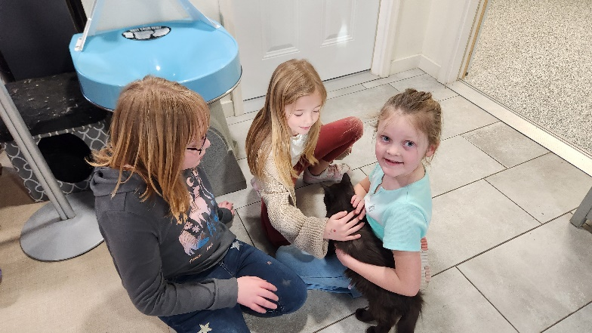

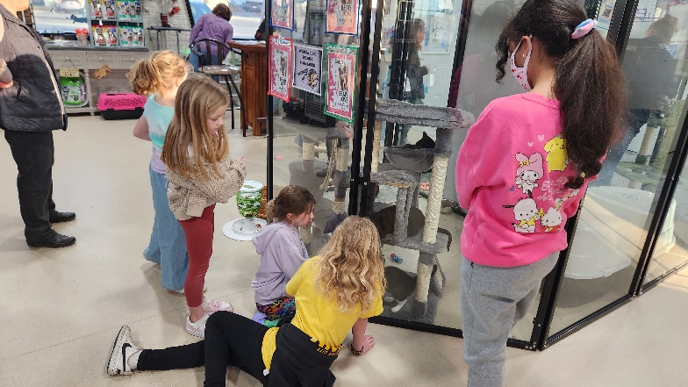



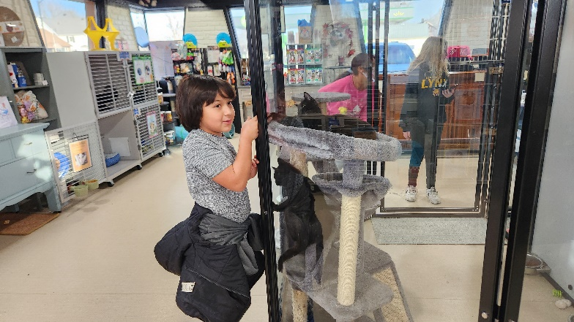

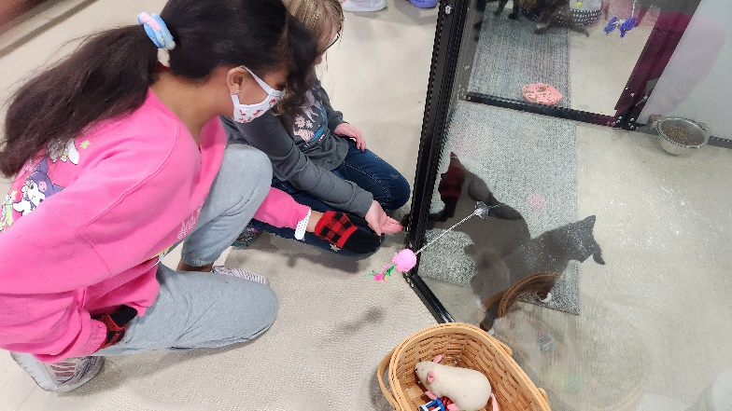

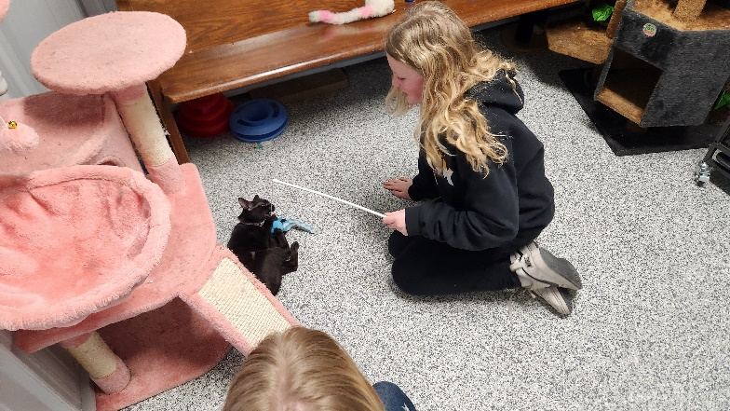

**Treasurer’s Report**

**INCOME December YEAR TO DATE**

Pledges and Offerings $23,202.34 $230,061.74

Other Income 0.00 .00

**TOTAL INCOME $23,202.34 $230,061.74**

**EXPENSES**

Outreach and Mission 1,250.00 $15,000.00

Pastoral Services 8,547.86 99,986.52

Maintenance and Repairs 5,662.53 41,934.95

Church Office 5,472.56 43,063.27

Music Ministry 717.25 6,357.00

Christian Education 55.11 318.16

Local Ministry 500.00 500.00

Misc. Expenses 7.70 2,455.33

**TOTAL EXPENSES $22,213.01 $209,615.23**

**First Congregational United Church of Christ**

Cabinet Meeting

January 20, 2025

Attending were: Gayle Olson, Dale Olson, Tracy Wehrhan, Curt McCoskey, Kolleen Taylor, Stephanie Hill, Patti Gescheidler, Cindy Henning, Carol Crystal, Pastor Craig Blaufuss. Absent: Neil Oberender-Trustees

The meeting was called to order by Gayle Olson-Moderator at 7:03 p.m. Pastor Craig Blaufuss led us in prayer.

Taylor read the minutes from the December 3 meeting. A motion was made by Henning to approve the minutes as read, McCoskey seconded.

**Treasurer:** Wehrhan reported this is the best year in a long time for offerings, with donations towards operations exceeding expenses. Donations for the Louver project in the bell tower have also been received and so far have collected $15,465 towards the building fund.

**Pastors Report:** We had a full Advent season with many ringing bells for Ecumenical Human Needs on the weekend of December 6-8, bringing in $3500. We showcased another Living Nativity on December 7, served a Beacon of Hope meal on December 9. December 13 we caroled at Southfield and Crestview. We enjoyed a wonderful and profitable Women’s Fellowship luncheon and auction held on December 15. December 24 we held our Christmas Eve service in our sanctuary beginning at 5 pm, concluding with candlelight and singing of Silent Night at its conclusion. I was gone for a week of vacation after that service and so on December 29, the worship board led worship with a video sermon in my absence. We observed Epiphany Sunday on January 5 and on January 12 we baptized Bryce Blackburn and baby Jessica Blackburn in a double ceremony. January 5 we led Care Center worship services and I led gospel hour services on January 8.

**WCMA:** The Webster City Ministerial Association met January 9 and had a long discussion about the Angel Tree project. We had over 400 angel applicants and the group decided we could not sustain those kinds of numbers, so we will return to requiring applicants to be screened by income. The group agreed that the applications would be modified to stress that the project is for Hamilton County residents only, that no gifts on the applicant lists were guaranteed, there would be no gift cards given out, and it is likely we will no longer allow bicycles to be gifts due to their expense. We also discussed the great response of the community to the EHN bellringing and the article in the Daily Freeman Journal. Sharon Perry submitted a grant to the Morrison Trust to benefit the Ecumenical Human Needs Fund and we received $11,000. We made over $5,000 ringing the bells and checks were sent to us totaling almost $25,000 in additional donations. An additional $7,500 was also received later from Dr. Subash Sahai, personally picked up Pastor Craig.

Adult education classes continue to study “Personal Christologies”. We have looked at Jesus as healer, as wisdom teacher, and now we are studying “The Atonement”, and what it means for Jesus to be our “Savior”.

**KLAB** has seven children attending. We studied Advent, the nativity, made and sold our KLAB Cat-Hut Fundraiser that was part of the Alternative Gift-Giving Fair, and raised $151. In January we started studying Epiphany. We will take a tour of the Cat Hut in a few weeks and give them our fundraising check.

**Shalom** Circle continues to meet most Fridays, the last two weeks of December were not held.

We hope to have the Ass. Conference Minister Kendy Miller in late January 20 to meet with 4 other churches who are looking for ministers to replace.

Since December 3, have led 10 worship services, led Christian Ed for Adults, attended 11 meetings, and had 12 visitations. My vacation was from December 25 to January 2.

**Boards & Committees:**

**Finance:** Met with the Trustees and asked for a 5 year plan. Agreed on $27,000 expensed for 2025.

**Trustees:** G. Olson read a written report submitted to her by Neil Oberender. Held a joint meeting with new Trustees, discussing the issues to be aware of in the future. At that meeting, an overall summary of the projects ahead that will need to be addressed. This included louvers, electrical, attic ventilation, belltower, sidewalk concrete and elevator pit. A presentation will be made at the Annual Meeting about the attic area, with three options. The three areas to consider are 1) Do nothing, 2) Hire Structural Engineer James Tometich, or 3) Tear off the attic. Lori Epps will not be at the Annual Meeting so she asked the Trustees to be prepared to help answer any questions that might come up. Questioned the procedure on handling money donated for the belltower project and how that impacts the budgeted amount, and if that can now be used for other projects perhaps needed on to-do list.

**Mission:** The Mission board last met on December 11. Project updates included the Angel Tree gifts, notified recipients that they had to be picked up on Dec. 15. Everything was sold on their Advocats tree. The auction held with the church dinner will included both a silent and open auction. The Beacon of Hope meal served on December 9 fed between 38 to 40 people. New information will be distributed soon on Kitchen signage. Bell ringing done our church totaled $3,204.41. Mission is responsible for the soups at the Annual Meeting on January 26, and selections were planned. New board members coming in January 2025. Lorraine McCoskey, and Karin Yungclas will join Pastor Craig Blaufuss, Sherry Leksell, chairman, Gayle Olson, Stephanie Hill, Susan Meinders, and Andrea Mosbach.

**Women’s Fellowship**: The Executive Board met December 4. Pastor Craig updated Executive Board on the other board activities and the Ministerial Association.The Funeral Policy has been revised and it was read and reviewed. The new policy will begin in January 2025. Cindy & Jim Henning will oversee training on using the dishwasher with Tracy & Glenda Wehrhan, Dale & Gayle Olson, and Curt & Lorainne McCoskey on Sunday, Dec. 8, 2024. Each couple will receive instructions on how to operate and steps needed to start and shutdown the dishwasher.

**Christmas Luncheon** will be Dec. 15 after worship. We will have a potato bar and dessert. Circle members will bring toppings. Patty made a sign-up sheet to get head-count. The Mission Board will also host an auction after the luncheon. Providence will set tables during their meeting on Dec. 13.

**Worship Board:** Hanging of the Greens: The November 24 decorating of the church for Christmas went quickly, thanks to the new somewhat smaller artificial trees. All decorations that have not been hung up or set out will go to a future Women’s Fellowship Thrift Sale. Laurie Epps and Cindy plan to take pictures to document where everything goes.

January 5 is the date for un-decorating. The Worship Board has signed up to host coffee fellowship that day. Marjorie will finalize the Annual Report, by adding information on the December-January activities.

**New Board**: To date, no one has signed up to take Jane’s place on the Worship Board. With fewer church members, we wonder if we can waive the rules and let Jane serve another 1-2 years on the Worship Board. She is willing. Tentative slate of officers: Co-Chair Gretchen and Marjorie; Cabinet Curt; Communion Cindy; Secretary Jane or new person.

**Communion**: January 5, Gretchen and Marjorie will be stewards. February 2, Cindy and Curt will be stewards. We need to remember to leave the elements at the organ for the accompanist unless the accompanist is Melissa Hindt.

**Accompanist:** Anne Sherve-Ose will be the accompanist December 8 and Josi Greenley will be the accompanist on Christmas Eve.

**Old Business:**

**Annual Meeting-** will be January 26 after Worship. Mission board is providing the soup; Cabinet members will contribute relish trays and desserts.

**Task Force Update:** Will need to survey the congregation to activate the search and call process with the United Church of Christ offices. The cabinet, if directed by congregational vote to start the search, will have to establish a Search committee. We have three options for replacing Pastor Blaufuss when he retires. 1) We can try to hire a Full Time Pastor, 2) Hire a Part-time or Shared pastor, or 3) Use Lay leadership (see the “Find Your Niche” signup list for volunteers).

**New Business:**

Endowment reported they gave $2,000 to the Bell Tower project, $1,000 to Angel Tree, $500 to Beacon of Hope and $500 to Lotus.

Phones: Some comments about phones ringing during service. It was asked that we gently remind people to put phones on vibration, on airplane mode, turn it off or leave it in car.

The meeting adjourned at 8:42 p.m.

Respectfully submitted, Kolleen Taylor, Church Clerk

FIRST CONGREGATIONAL UNITED CHURCH OF CHRIST

**Address Service Requested**

God is still speaking

to everyone in the home of:

