**March 2025 Newsletter**

**First Congregational United Church of Christ**

**1000 Willson Avenue - Webster City, Iowa 50595**

**515-832-2232**

[**http://www.firstcongregationalwc.org/**](http://www.firstcongregationalwc.org/)

*“Therefore if anyone is in Christ, there is a new creation; what is old has passed away; behold, what is new has come!” -2 Cor. 5:17*

I want to ask you a question; more of a thought experiment, really. Imagine you are going to play the role of Jesus in a play or a movie. How would you portray Jesus? And how would you do in the role? Would you get lost in it? Would you be convincing, or unconvincing? Would it change you?

OK—I know it’s a preposterous idea, but it may well be a useful one. Because if you are a Christian, there is an inner image of Christ in you…an idea, a vision of who Christ is for you. I’m just asking you to take that inner image, bring it out, show it to the world --and yourself-- by acting it out on the great screen of your life. Can you imagine for even a day saying to yourself “OK, today I will play the role of Jesus Christ as I understand him to be…and I will play it as convincingly as possible. I will lose myself like a good actor in this role until it is no longer I, but Christ, living in me.”

Would you balk at this assignment? Would you tremble at this assignment? Would you not even consider it because it would be such fraud, such a lie to even attempt such a thing—you be Christ-like for a day?

Why else wouldn’t you consider it? Because you know what you would have to give up to be Christ-like—even for one day?

I know what I’d have to give up…I’d have to give up my well-worn groove of a self that is a pile of old memories and life experiences and preferences and wants and desires. Every day I wake from sleep and put on this old self like a well-worn set of jeans or a favorite old coat or hat. Every day I see through the vision of this old self; I see through lenses I have ground over a lifetime with a whole lot of help from a whole lot of sources, so that I see in old, well-worn ways that suit this old, well-worn world. Every day I scarcely think of who I am or who I could be. I just suit up in my old clothes, put on my old lenses and my old ears, my old ways of thinking, my old ideas about myself and others and the world and life…every day I put on my old conditioning that helps me navigate through another day.

And so to put on Jesus, to become a new creation…that’s a big ask! For Jesus is new, and he’s awake, and something different is in him that you can see and feel. Just his presence is a catalyst; it’s like he is a new species of human, so alive, radiating light and love…and in him you feel the summons to outgrow yourself; to die to your old life. His life is calling you; his light is summoning your inner light to come alive at last, and in his presence you must either *die* to live in newness of life…or continue living your old life by dying to what he brings to you, which is Christ-LIFE. And while it may seem laughingly impossible that we could ever be Christ-like, even for 24 hours of role playing,

let me remind you that with God, nothing is impossible. At least for the one *who believes.*

Friends, there is an image of the Christ in all of us who profess to be Christians. Your faith and devotion can flesh that inner image out, even as an actor can flesh that inner image out with their portrayal of Jesus. Let that inner image inspire you…let it change you…let it grow in you… until it leads you to the new creation of your new life. To my mind that is the inner alchemy, the inner miracle, for which Jesus came. This is the transfiguration that is possible on more than just a mountain top in ancient Israel. It is a transfiguration that can happen in each of us.

Lent is now at our doorstep: a season of life, and death, and resurrection to new life. May our love for Jesus lead us through Lent to celebrate the wonder of his resurrection! And may our love for him bring forth our “Christ-lives” as well, so we too can experience a resurrection to the new life he came to offer us--through his life, and his love.–Pastor Craig

**Church Staff**

**Rev. Craig Blaufuss,** Pastor

Office: **832-2232** Cell **297-4316**

Pastor’s email: **revcraigblaufuss@gmail.com**

**Michele Omvig:** Admin. Assist. **269-7210**

Church’s e-mail**:** [**administrative.office@fcuccwc.org**](mailto:administrative.office@fcuccwc.org)

**Melissa Hindt:** Organist **712-351-1074**

**Curt/Lorraine McCoskey:** Cust’s. **832-5341**

**Tracy Wehrhan:** Church Treasurer **297-0370**

**Dale Olson:** Financial Secretary **839-5619**

**CHURCH OFFICE HOURS**

M 8 am - 1 pm

T 9 am – 1 pm

W 8 am – 4:30 pm

Th 8 am – 4:30 pm

F 9 am – 1 pm

**HAPPY BIRTHDAY TO:**

4 - Vicki Blaufuss

6 - Jennie Williams

8 - Vada Williams

13 - Shirley Yungclas

16 - Craig Blaufuss

19 - Kaleb Butz

20 - Verna Bierle

20 - Jacob Meinders

22 - Jayden Burgos

23 - Todd Sonsalla

23 – Eve Sonsalla

23 - Jose Burgos

28 - Jackson Leman

**HAPPY ANNIVERSARY TO:**

7 - Robert & Mary Van Diest

15 - Curt & Lorraine McCoskey

**Lent Begins March 5**

First Congregational will begin the observance of Lent with an Ash Wednesday Service on Wednesday, March 5, beginning at 5 p.m. in the East Chapel. Ash Wednesday is a day of penitence and preparation which begins our Lenten season; it is a day which reminds us of our mortality, and our need for repentance and renewal. We will observe Ash Wednesday with the Imposition of Ashes, and share the sacrament of Holy Communion.

**Shrove Tuesday Pancake Supper March 4**

Shrove Tuesday is an old tradition that prepared for the austerity of the Lenten fast by using up all the eggs, butter and fat in a household prior to Ash Wednesday. And what better way to use up those ingredients than to make pancakes! On Tuesday, March 4, from 5-6 p.m. we will host a Pancake Supper in Fellowship Hall, with a free-will offering to offset the cost of the meal. There will be a pancake bar with various toppings for your pancakes, eggs, sausage links, coffee, juice, milk, and water. There will be gluten-free pancakes as well! Join us for a great pancake supper on the eve of Lent!

**The Shalom Circle Continues During Lent**

The Shalom Circle, our prayer and meditation group, will continue to meet during Lent. If you have not yet chosen a Lenten discipline, the circle is a wonderful opportunity to explore spiritual practices and deepen your prayer life. We have a place for you in the East Chapel; if you are interested or want to know more, please speak with Pastor Craig.

**Lenten Lunch**

The lunch will be Tuesday, April 8, noon to one at Trinity Lutheran Church Social Hall. The cost is $12 and must be prepaid to 1st Congo. A sign-up sheet will be in Fellowship Hall.

**Adult Education topic: Intuition and Inspiration**

Our next topic for our Adult Education class will be “Intuition and Inspiration.” Have you ever had a “hunch” about something that you couldn’t explain? Ever had a premonition? Do you have dreams that seem to hold special meaning about your present—or your future? Do walks in nature, listening to music, being creative, or sitting in prayer or meditation inspire you? Join us beginning at 9 am on Sunday, March 2 in the lower level of the church as we explore our experiences of intuition and inspiration.

**NO KLAB March 4 and March 11**

Due to parent/teacher conferences and Spring Break there will be no KLAB on March 4 and 11. We will resume class on Tuesday, March 18!

**Search Committee**

The Search Committee is in place. Members are Joyce Gelhaus, Lorraine McCoskey, Stephanie Hill, Patty Gescheidler, Les Ploeger, Curt McCoskey, and Wil Groves.

After a brief organizational meeting we contacted the conference office and found out we will be assisted by Rev. Jeff Hagaman, the conference Search and Call Minister. The information we need to get started has been sent. Our first formal meeting will be Tuesday, February 25 and Rev. Hagaman will join us via phone. He lives in Crete, Nebraska, so will probably not meet with us in person for any meetings.

This is an enthusiastic committee and all are ready to get started on this important next phase of the church life. We will most certainly be asking for the congregation’s help throughout this process, so when you are asked, please respond truthfully, honestly, and promptly.

**Trustees Update**

1. Bell Tower- We are waiting for an estimate of repairs on the bell tower by the end of March.

2. Elevator- Schumacher repaired and we are getting an estimate for removal of the Black Mold. 3. Electrical Box- We will put in the new electrical box that has been approved. 4. Roof- We have a local company to check the roof when the weather warms up.5. Lawn- Working on bids for lawn care, mowing and sidewalk cleaning.

**OCWM**

In isolation, no single congregation can completely answer God’s call to love. We share resources to transform our vision into reality. Gifts from congregations like ours to OCWM Basic Support make it possible for our Conferences and the National Ministries to strengthen local churches and leaders and engage us in mission well beyond our community. Most of our OCWM Basic Support dollars remain in our Conferences to help local congregations thrive. The National Ministries of the UCC, a crucial partner of our Conference and each congregation, helps us put love into action. The National Ministries are organized into these three categories:

[**Love of Church**](https://www.ucc.org/justice-local-church-ministries-2/) supports congregations and other settings of the church in doing justice, seeking peace, and building vibrant faith communities that are welcoming to all.

[**Love of Neighbor**](https://www.ucc.org/wider-church-ministries/) encourages and supports local churches, Associations, Conferences, and the national expressions of the United Church of Christ to participate in the global, multiracial, multicultural church

[**Love of Service**](https://www.ucc.org/what-we-do/office-of-the-general-minister-president/) is responsible for administration and common services for the National Setting. The Love of Service Ministry oversees the finance office, human resources, legal counsel, ecumenical and interfaith relationships, the UCC Resources Store, strategy and planning, philanthropy, technology, UCC Archives, and marketing and communications.

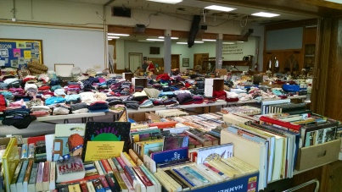

**THRIFT SALE**

Fri., April 25th & Sat., April 26th Women’s Fellowship will be conducting their semi-annual Thrift Sale.

Wed. April 23rd & Thurs. April 24th -

* Drop Off Donations
* Set-Up items on tables

NO - large items or furniture, but donations to Beacon of Hope and Lotus are encouraged.

Remember items should be clean, complete, and in good repair. Workers can sign-up in Fellowship Hall or at your circle meeting.

All church members are encouraged to sign-up.

Contact Cindy Henning at 297-0422 or [bestgrandmacindy@gmail.com](mailto:bestgrandmacindy@gmail.com) with questions.

Thank you for your donations and help making this fundraiser a success. Cindy Henning

**Banquet**

GoServe Global is hosting their annual fundraising banquet on March 29 at Briggs Woods Conference Center. Doors open at 4:00 pm, dinner is served at 6:00 pm. RSVP by March 17 goservglobal.org/banquet/

More information is on the bulletin board.

**12 to15 adults usually attend adult Sunday school on Sundays at 9 a.m. OCWM**

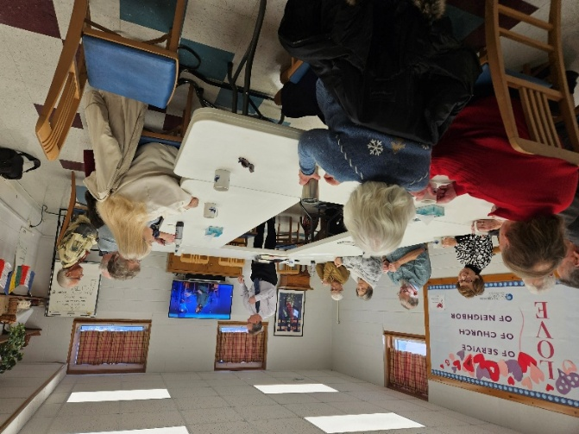

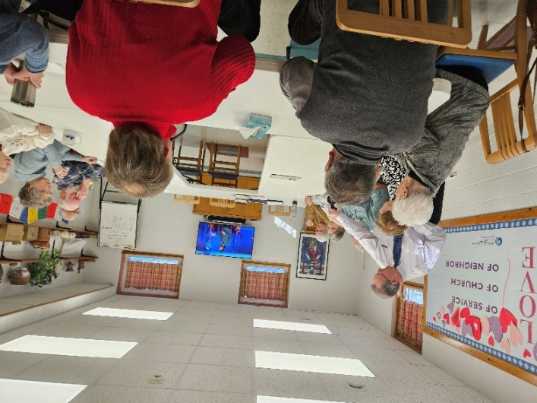

**We did it! We built a tower of Cottonelle to the ceiling in fellowship hall! Thanks to everyone who donated paper goods in February. They will be taken to UDMO for distribution.**

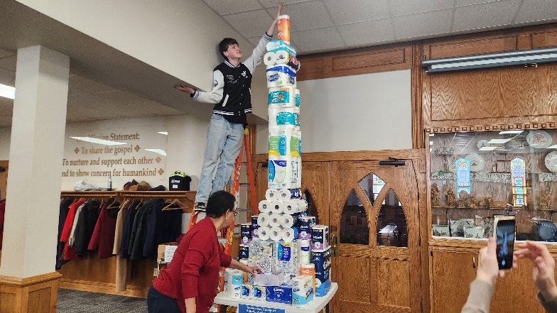

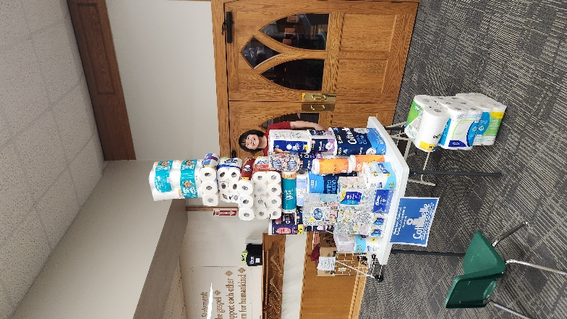

**The KLAB kids enjoyed their annual Valentine's Day party on Feb. 11. Sweets for the sweet!**

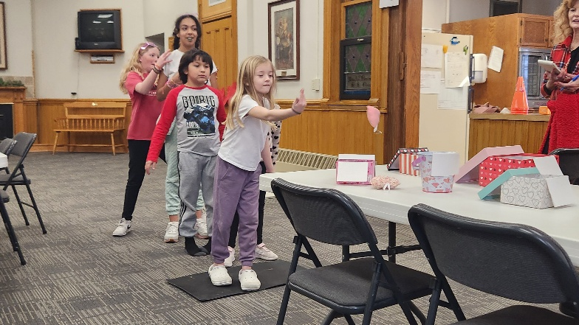

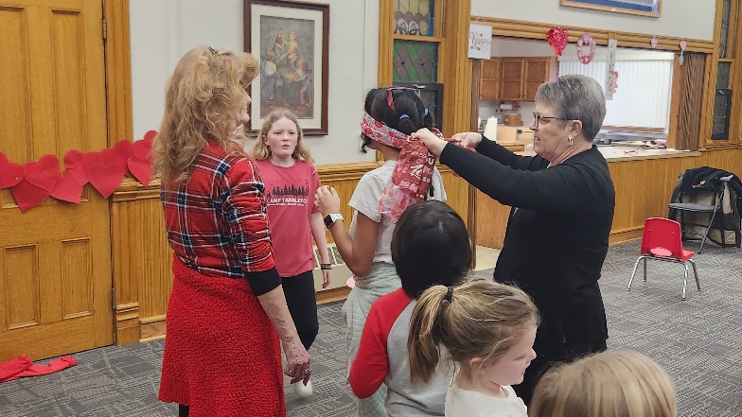

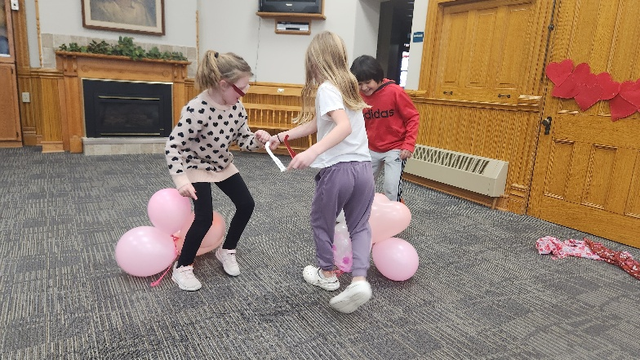

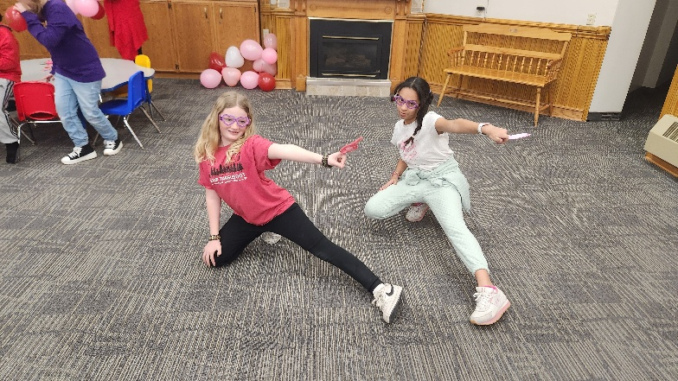

**Treasurer’s Report**

**INCOME January YEAR TO DATE**

Pledges and Offerings $16,131.78 $16,131.78

Other Income 0.00 .00

**TOTAL INCOME $16,131.78 $16,131.78**

**EXPENSES**

Outreach and Mission 1,250.00 $1,250.00

Pastoral Services 8,051.23 8,051.23

Maintenance and Repairs 1,578.58 1,578.58

Church Office 3,526.79 3,526.79

Music Ministry 550.00 550.00

Christian Education 0.00 0.00

Local Ministry 4.27 4.27

Misc. Expenses 405.48 405.48

**TOTAL EXPENSES $15,366.35 $15,366.35**

**First Congregational United Church of Christ**

Cabinet Meeting

February 11, 2025

Moderator Curt McCoskey called the meeting to order at 7:00 p.m. with the following members in attendance - Lorraine McCoskey, Kolleen Taylor, Dale Olson, Tracy Wehrhan, Patty Gescheidler, Gayle Olson, & Pastor Craig Blaufuss. Absent - Carol Crystal. Pastor Craig led us in a prayer. Minutes from the January meeting were read. There was a correction in the Trustees report - it should read Nick Oberender instead of Neil Oberender. Dale Olson moved to approve the minutes as corrected, Lorraine seconded. Motion passed. **Treasurer’s Report** Tracy reported that everything is in line for the first month of the year. It was noted that under Pastoral Services expenses for the month and expenses for the year should both read $8,054.23. Tracy moved to put the corrected report to audit, Patty G. seconded. Motion passed. **Pastor’s Report** Shrove Tuesday Pancake Supper will be Tuesday March 4. He will be recruiting volunteers. Ash Wednesday service will be at 5p.m.on March 5 in East Chapel. WMCA is meeting February 12 in our Fellowship Hall. EHN will be discussed. KLAB students are again doing art projects for the UCC Climate Hope Art Contest. A Valentine’s party was enjoyed by all on the 11th. No KLAB the first 2 weeks in March. Task Force & Cabinet met with Kendy Miller on January 20 to discuss ways of moving forward with shared ministry if that is what the church decides. **Finance Board** has not met. **Trustees** Working on prioritizing needs of the church. Tometich Engineering has been contacted. Ideas for other groups renting the church for other uses was discussed. **Mission** Collecting clean, label & glue free empty pill bottles for Almost Home. February collecting paper goods for food pantry. **Women’s Fellowship** Lenten Luncheon - April 8 12:00 at Trinity Lutheran Church. Patty will be our part of the program by reporting on the projects we are doing in the community. If you have projects you want mentioned please talk to Patty. Spring Thrift Sale - April 25 10-6 and April 26 8-12 with set up earlier in the week. Women’s Fellowship May dinner will be Wednesday May 21 at 5:30. **Worship** Ash Wednesday service - March 5 East Chapel. 5:00 pm Maundy Thursday service - April 17 East Chapel 5:00 pm. **Christian Education** No graduates or confirmands this year. Adults working with young people in the church need to have a meeting with Pastor Craig to go thru the Safe Church Policy of the church. A date will be set in the near future. **Staff Parish** No report. **Old Business** Bell Tower - Tometich Engineering was here February 7, 2025. A report from them will be forthcoming in the next 30 days. **New Business** Cabinet meeting times will remain the 2nd Tuesday of the month at 7 pm. Boards and committees please give the names of your Chairs and Cabinet Reps to Michele in the church office ASAP. Updating the Constitution was discussed - tabled for now. Search Committee - Curt reported he has had 3 volunteers for serving on this. Cabinet suggested other names for him to contact to see if they would be willing to also serve. 6-7 people are needed for this committee. Question was asked about membership in 2 different churches. Craig saw no problem with dual membership when people are active and participating in our church. Discussion ensued. Next meeting -March 11 7 pm. Meeting adjourned at 8:30

FIRST CONGREGATIONAL UNITED CHURCH OF CHRIST

**Address Service Requested**

God is still speaking

to everyone in the home of:

