**May 2025 Newsletter**

**First Congregational United Church of Christ**

**1000 Willson Avenue - Webster City, Iowa 50595**

**515-832-2232**

[**http://www.firstcongregationalwc.org/**](http://www.firstcongregationalwc.org/)

*“I therefore, the prisoner in the Lord, beg you to lead a life worthy of the calling to which you have*

*been called, with all humility and gentleness, with patience, bearing with one another in love, making*

*every effort to maintain the unity of the Spirit in the bond of peace.  There is one body and one Spirit,*

*just as you were called to the one hope of your calling, one Lord, one faith, one baptism, one God*

*and Father of all, who is above all and through all and in all.” –Ephesians 4: 1-6*

*“The great Tao flows everywhere, both to the right and to the left. The ten thousand things depend*

*upon it; it holds nothing back. It fulfills its purpose silently and makes no claim.” --Tao Te Ching 34*

Recently I was told “he is in everything.” It was a subtitle of a book written by a believer…who told

me this good news. She believes it-- or wants to believe it.

Does she know it?

Do I?

I want this to be true, and I believe this is true…but I don’t know this to be true (at least most days).

I don’t know this because I don’t feel it, and feeling is knowing here. God is either in all things, or not

…and feeling this…knowing this…is peace. Not knowing this is perpetual suffering, wondering, and

doubt.

What do you think? Is It true? Could it be true? How could it not be true? When your heart is fully

opened…would you withhold your love? Would you withhold your goodwill? Would you withhold your

deep need to meet; to greet; to embrace; to share, and be joined with an unbreakable bond?

God wants to be in all things. This is “heaven.” And there is room in all things for God, for God takes

nothing--not even room. God only gives, and this giving is presence and peace and the eternal

assurance that you are not a lone fragment of a fragmented universe. All is one; God makes it so-- for

God is in all things.

You can share this power, this gift, with God. You can join your presence with every other presence.

You can let go of fear; of boundaries; of needing to stand apart and separate.

This “let go” will let you go out of your small self, and join all things. And you will be welcomed to

join! For you will be bringing love… and love joins all.

And in this going out, this joining through love… you will find God has room for you; LIFE has room

for you; ALL has room for you. For you, like God, will no longer take anything-- not even room.

You will give, like God…and so, like God, you will belong: everywhere, and in everything

*–Pastor Craig*

**Church Staff**

**Rev. Craig Blaufuss,** Pastor

Office: **832-2232** Cell **297-4316**

Pastor’s email: **revcraigblaufuss@gmail.com**

**Michele Omvig:** Admin. Assist. **269-7210**

Church’s e-mail**:** [**administrative.office@fcuccwc.org**](mailto:administrative.office@fcuccwc.org)

**Melissa Hindt:** Organist **712-351-1074**

**Curt/Lorraine McCoskey:** Cust’s. **515-297-0261**

**Tracy Wehrhan:** Church Treasurer **297-0370**

**Dale Olson:** Financial Secretary **839-5619**

**CHURCH OFFICE HOURS**

M 8 am - 1 pm

T 9 am – 1 pm

W 8 am – 4:30 pm

Th 8 am – 4:30 pm

F 9 am – 1 pm

**Reminder! If you change your phone #, or drop a phone line, please notify the church!**

***Happy Mothers’ Day to all our Mothers!***

**HAPPY BIRTHDAY TO:**

11 - Lauren Leman

11 - Mabel Prescott

19 - Gretchen Bruner

22 - Ed Mosbach

22 - Sue Jaycox

26 - Carol Crystal

28 - Kasyn Weig

29 - Linda Lahr

**HAPPY ANNIVERSARY TO:**

7 - Craig & Vicki Blaufuss

17 - Tracy & Glenda Wehrhan

28 - Diana & Nick Oberender

**Scholarships**

Applications will be available by May 1 and will be due June 16.

**Congregational Meeting**

On Sunday April 27th following worship, a congregational meeting was held for the purpose of amending the 2025 budget by $74,000 for the repair of the bell tower and other repairs to the building. After an explanation by members of the Trustees about the work to be done and the cost involved, there was a question and answer discussion. After the discussion, it was moved to amend the budget by $74,000. It was approved by a vote of 34 yes, versus 4 no (including absentee ballots). Work will begin immediately and hopefully in a couple of months all the work will be completed.

*Moderator Curt McCoskey*

**Plymouth Circle had an Easter parade at their April 10 meeting.**

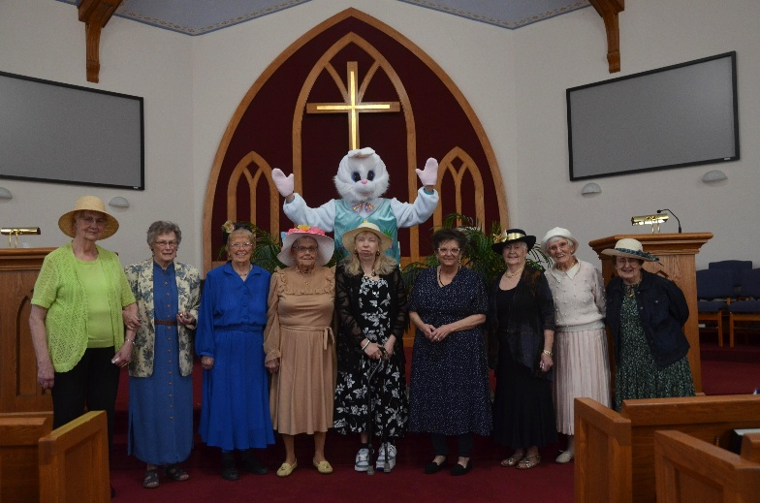

**Shalom Circle Continues**

The Shalom Circle continues to gather weekly whenever possible, usually on Fridays beginning at 6:30 p.m. Join us in East Chapel as we experience Shalom through prayer, meditation and silence!

**Generosity**

On April 11 our church was blessed to receive this generous donation of $9,543.67 presented by Margy Wood, who has created the Margy Wood Legacy Fund which will be administered through the Okoboji Foundation. First Congregational will receive a yearly distribution thanks to Margy's foresight and dedication to our church. Thank you so much, Margy!

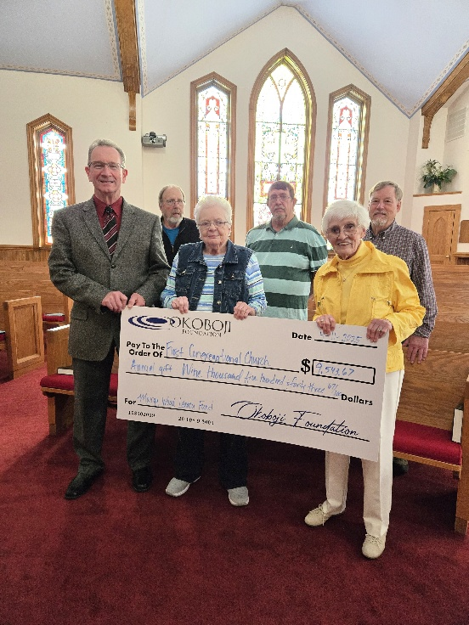

.

**Adult Education topic: The Cost of Compassion**

TheAdult Education class begins a new study of "The Costs of Compassion." One of the enduring messages of Christianity is about compassion and its costs that we are to willingly bear as disciples of the one who paid the ultimate cost for his compassion. We will also explore what boundaries/limits we will set in our acts of compassion, and what values and understandings we will use to determine those boundaries.

**Earth Day Clean-up!**

On April 14 KLAB and adult volunteers did a trash pickup at the retention pond and along the Boone river trail. This project was a joint collaboration of the Mission Board and KLAB.

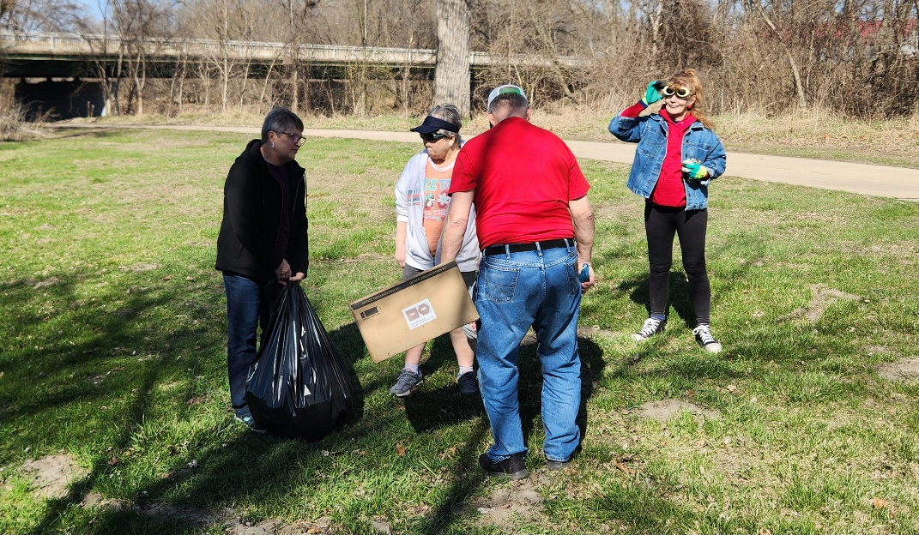

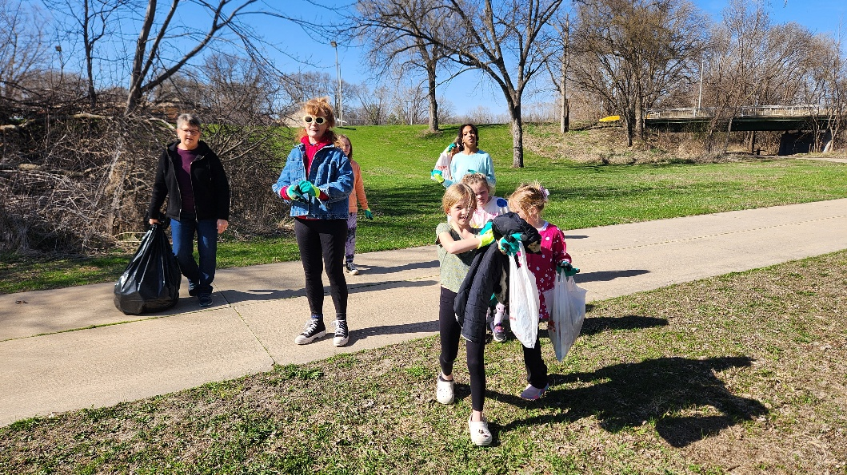

**NW Association Takeaways**

A lovely but long (150 miles) drive got me into Loess Hills and to the Whiting UCC for the annual meeting of the Northwestern Association April 26. I have been on the NW task force to update and revise the association’s bylaws. Meeting delegates approved them.

The Offering went to Whiting UCC youth group project Sleep in Heavenly Peace, an organization that makes beds and supplies bedding for kids without them.

The Northwestern Association elected Dale Olson (yes, our Dale) to be its treasurer. Offices of moderator, vice moderator, and secretary are open. Please contact Rev. Burtnett soon if you are interested or have nominee to suggest. His email is [cpburtnett@netamumail.com](mailto:cpburtnett@netamumail.com).

Long-time association moderator, Rev. Burtnett, Audrey’s son, resigns as pastor of the Algona UCC and Northwestern Association in August and moves to Ames (Central Association). The Northwestern Association’s future is uncertain.

Rev. Roberto Ochoa, Tri-Conference minister, views us as three separate conferences with a single administrative office. Iowa, Nebraska, and South Dakota each have their separate goals and business. He goes by Rev. Roberto and has a home base in each state.

Rev. David Boogerd, Klemme and Belmond UCC, and a member of CCAM (Conference Committee on Authorized Ministry), says the Tri-Conference has 14 Members in Discernment, with two interviewed by Zoom on Maundy Thursday.

Rev. Boogerd noted that there are MIDs from Iowa, but their names can’t be announced yet. CCAM also collaborates with pastors who want to work in the UCC but are from other denominations. UCC has reciprocity with Evangelical Lutheran Churches of America (ELCA), Presbyterian Church USA (PCUSA), United Church of Canada, Disciples of Christ, United Methodist Church, and the Episcopal Church, so pastors in those churches can have standing with the UCC.

Manson UCC is closing and has sold their building to the city. The Eagle Grove UCC has closed. The Algona church will become a legacy church and no longer hold services but will be available for events and community groups; their endowments will maintain the church. Most other churches at the association gathering have a part-time pastor, use pulpit supply, or are in (or will be in) the search process.

Pilgrim Heights camp and retreat center is alive and kicking, says Rev. Burtnett. They are in the most solid financial condition they have been in for years. Pilgrim Heights is booked solid all summer and busy the rest of the year with reunions, weddings, camps hosted by Pilgrim Heights, and camps hosted by other groups. The camp and retreat center is called both Pilgrim Heights and Our Sacred Ground. It is the same place. Email address is [office@pilgrimheights.com](mailto:office@pilgrimheights.com). Thank you for sending me as the First Congregational UCC lay delegate to the NW Association Meeting. *Marjorie Groves*

**Search Committee**

A church profile is a lengthy, detailed document about our congregation that introduces a potential pastoral candidate to our church and community. Search committee has been working on this the past several months.

You’ll soon receive a survey questionnaire asking for information and input from members and selected non-members who actively participate in our church life.

One section asks for a demographic picture of our membership—numbers, ages, occupations, households, and so on. That’s the easy part. Just answer the questions, anonymously if you prefer.

Next part is tougher, questions that may require prayerful thought and consideration. Answers will help guide us to the type of person we need to lead us on the next stage of our congregational life. Here are examples:

* What challenges and opportunities await us in the next few years?
* What are strengths and weaknesses of our congregation?
* Who is God Calling us to become as a congregation?

When you complete your questionnaire, please return it by mail or drop it at the church office. We hope to have this part of the profile completed by June 1.

Wil Groves

Joyce Gelhaus

Patty Gescheidler

Les Ploeger

Stephanie Hill

Curt McCoskey

Lorraine McCoskey

Thank You

Thank you for all the prayers, cards and get well's while I've been ill.

*Vicki Blaufuss*

**Easter Breakfast**

April 20 was our Easter Breakfast preceding worship, hosted by the Christian Ed. Board. He is Risen!

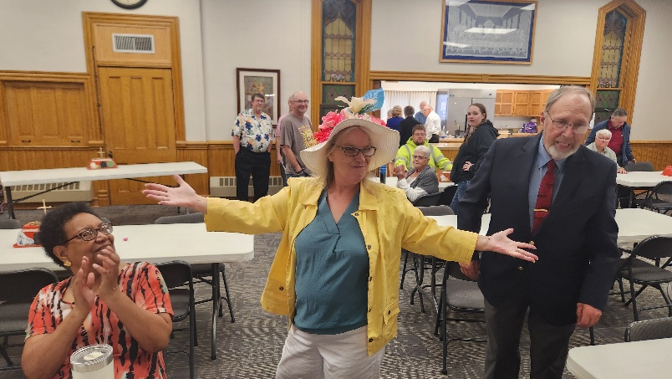

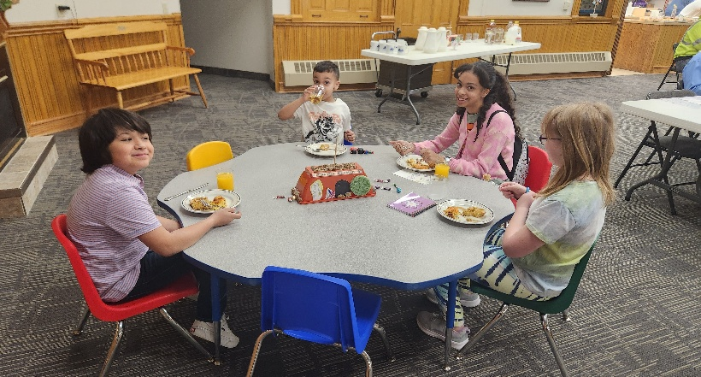

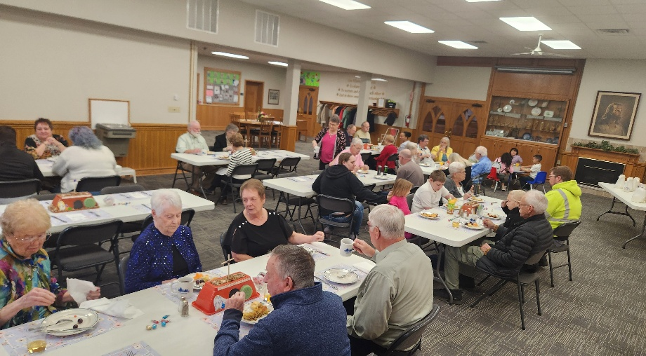

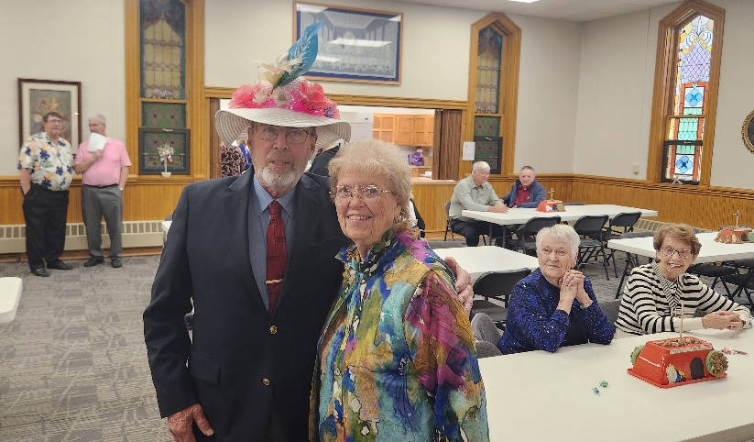

**THRIFT SALE!**

April concluded with another fabulous Thrift Sale! Over $1,800 was brought in!

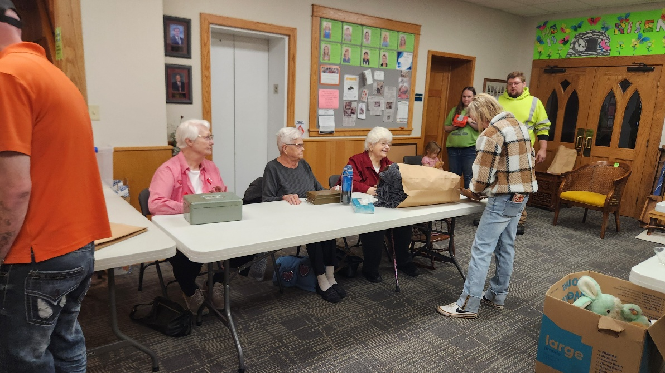

**Thrift Sale update from Cindy & Jim**

Thanks to everyone who helped with the spring thrift sale. Again it was a huge success! We raised about $1800. I want to thank the entire church family for pulling together to help make this a success. We had new faces helping bring items up on Monday and many faces to help set things out throughout the week and to clean up at the end. 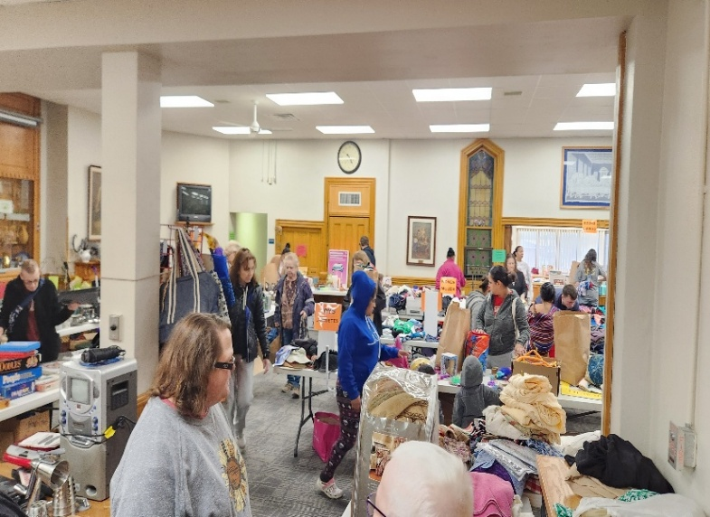

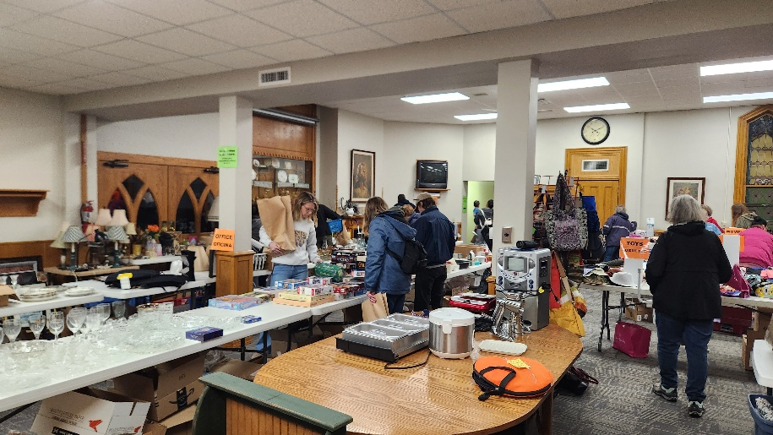

*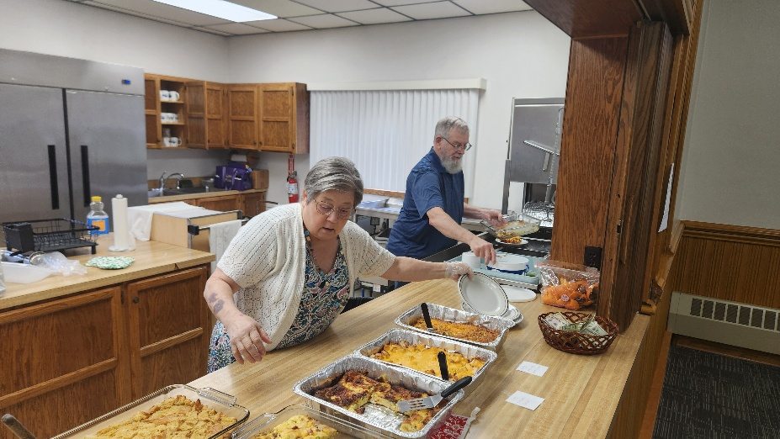Thanks Jim & Cindy for your work on both the Easter Breakfast & Thrift Sale! Many helpful hands for both events!*

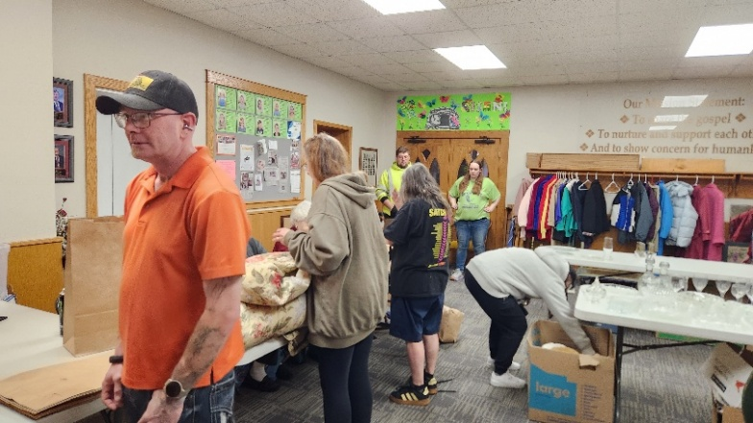

**Summer Lunch Update:**

The Mission Board has signed our church up to serve the summer lunch program for the week of June 2-6.

Lunches will be served on Monday, Wednesday, and Friday.  We need your help contributing items for the meals, preparing and serving.  
 Please look for sign up sheets to see how you can help with this project.

**Thank You…**

*Jim and I would like to thank you for supporting us as I heal from my broken arm and especially for helping with the Thrift Sale.*

**Everyone**

**Is Invited!**

**Women’s Fellowship May Dinner**

**May 21 @ 5:30 PM**

**We would appreciate an RSVP by May 19 by calling the church office or**

**signing up on the sheet in Fellowship Hall. Come and celebrate with us!**

**Salads & Dessert**

**Announcement of Program Year Proceeds Awarded to Local Organizations**



**Treasurer’s Report**

**INCOME March YEAR TO DATE**

Pledges and Offerings $16,612.28 $49,619.06

Other Income 0.00 .00

**TOTAL INCOME $16,612.28 $49,619.06**

**EXPENSES**

Outreach and Mission 1,250.00 $3,750.00

Pastoral Services 8,591.53 25,361.99

Maintenance and Repairs 5,662.53 8,819.66

Church Office 3,004.81 10,442.63

Music Ministry 700.00 1,800.00

Christian Education 21.40 55.64

Local Ministry 0.00 4.27

Misc. Expenses 280.58 717.85

**TOTAL EXPENSES $19,438.85 $50,952.04**

**First Congregational United Church of Christ**

**Cabinet Minutes April 8, 2025**

Moderator Curt McCoskey called the meeting to order at 7:00 p.m. with the following members in attendance: Tracy Wehrhan, Dale Olson, Gayle Olson, Lorraine McCoskey, Alan Yungclas, Patty Gescheidler, Kolleen Taylor, & Pastor Craig Blaufuss.

Pastor Craig offered a prayer to start our meeting. Minutes from March were approved as written on a motion by Tracy and a second by Kolleen. Motion passed.

**Treasurer’s Report** - Tracy reported March expenses exceeded income by close to $3000.00 but much of this is due to quarterly expenses being paid at this time. He also noted percentages spent are on track for the year. Tracy moved to put the report to audit, Dale seconded. Motion passed.

**Pastor’s Report** - Pastor Craig noted Nolan Thomas Oberender will be baptized Sunday April 13. Maundy Thursday service on April 17 will be held at 6 pm in East Chapel. Easter worship time will be 10:30. Ecumenical Human Needs could use another volunteer or 2 to meet with clients. Summer lunch program will run from June 2- August 11. Ministerial Association is hoping to recruit sponsors to help offset costs to churches. KLAB and Mission Board are sponsoring a trash clean up time on April 15. Craig will be leading a workshop on creating and leading worship services on Thursday April 10 at 6:30. The NW Association Annual Meeting is to be held in Whiting Iowa on Saturday April 26 9am-1pm. There is concern about what the future of this association is going to be as the current president who has held the position for several years is retiring and people are unsure about leadership.

**Mission Board** - a sign up sheet is out for adults to sign up to help with trash pickup in partnership with KLAB. Our church has signed up to serve summer lunch the week of June 2. We will be serving M,W,F. Sign-up sheets will be out for the meals that are planned. We will host coffee fellowship after worship on April 27 and have the pickle jar out for Disaster relief donations. We will do something for electrical line workers in appreciation for all they do.

**Finance Board** - met and reviewed the current scholarship application and made some minor changes. Applications will be available on May 1 and be due June 16. Discussed the endowment gift from Margie Wood. This money will be put into the general fund to be used for expenses. Held a joint meeting with Trustees where Trustees updated them on their recommendation for repair to the bell tower. They are going to ask the congregation to amend the budget for $67,000 for repairs.

**Women’s Fellowship** - Thrift Sale will be Friday April 25 10-6 and Saturday April 27 8-12. Cost will be $7.00/bag this year with bags also being larger. Women’s Fellowship May dinner will be Wednesday May 21 at 5:30 with circles bringing a variety of salads. Worship - Easter worship time will be 10:30 to accommodate Josie Greenley who will be our organist. Christian Education - Easter breakfast will be served starting at 9 on Easter Sunday. Staff/Parish - Kolleen reported she paid for a membership to the Chamber in our church’s name. As of now Craig is the contact person for it.

**Trustees** - Cancelled snow removal and mowing contract with Tony Jones. Quotes are being gathered for a replacement. Matt Byrne is going to be running camera down the cistern in front of our west door to see if it is tied into the city storm sewer or where the openings lead. Hopefully this can be filled in and covered with concrete with the manhole removed. Someone has volunteered to pay for this. Elevator issues are still being worked on. Peterson Construction has been notified they have the go ahead to put the new electrical box in based on their bid from May of 2022. Jim Vesey, a mason, has been to the church and looked at the bell tower with Tometich Engineering. Mr. Vesey has submitted a bid to repair the bell tower, finish some work in the elevator pit, put vents in the gable and work with Chris McNeil to put fans in for ventilation, as well as making several other repairs to the outside of the church. The total for all of this work was $74,000 with about $56,000 for the bell tower. Much discussion followed with questions about qualifications needed for this project, unexpected costs that could be incurred, and the need for a performance bond, whether a bid has been received for removing the top part of the bell tower. A motion was made by Kolleen to set a congregation meeting for Sunday April 27 following worship on the proposed options the congregation asked for at the annual meeting concerning the bell tower. Lorraine seconded. Motion passed with 7 ayes and 1 nay.

**Old Business** -Search Committee meets next Tuesday April 15. They are working on putting together a questionnaire for the church in regards to what we would like to see in a new pastor. They did say they were wanting input from all and will be asking those who are active in our church even if they are not members for their input as well.

**New Business** - Boards are asked to include Michele in email exchanges that concern meeting time and place. Kolleen moved and Dale seconded that Marjorie Groves be asked to be our delegate to NW Association annual meeting. Motion passed. We are entitled to 1 other delegate if anyone would like to volunteer. Question was asked if non-members could vote and the answer is no.

Next meeting will be Tuesday May 13 at 7:00 Meeting adjourned at 8:40.

*Respectfully submitted Gayle Olson*

FIRST CONGREGATIONAL UNITED CHURCH OF CHRIST

**Address Service Requested**

God is still speaking

to everyone in the home of:

