**June 2025 Newsletter**

**First Congregational United Church of Christ**

**1000 Willson Avenue - Webster City, Iowa 50595**

**515-832-2232**

[**http://www.firstcongregationalwc.org/**](http://www.firstcongregationalwc.org/)

*“For I am about to do a new thing; now it springs forth; do you not perceive it?” –Isaiah 43:19*

*“Awe came upon everyone because many wonders and signs were being done through the apostles.” –Acts 2:43*

Summer is almost here! Have you been “astonished” lately?

Yep—astonished. When was the last time you had an experience that was so unexpected, so extraordinary, so miraculous…that you were astonished?

Have you recently been astonished by nature? Perhaps when you were struck by the beauty of a peony, or the green-ness of the grass, or the wide sweep of the sky? Remember our talk about ants during one of our Short-Takes in worship? There are anthills EVERYWHERE, and they are making their mounds ever higher…astonishing ant-skyscrapers created by colonies of very ambitious ants!

Have you recently been astonished by your daily life, seen suddenly and surprisingly in new ways? Have you looked in your clothes closet and been astonished at how all of this ATTIRE has come into your household—a wealth of clothing that would have been unthinkable to our pioneer ancestors who made all of their attire by hand, with needle and thread? I recently replaced my garage door opener, and I was astonished by: 1. The weight of the garage door when you have to lift it by hand, 2. the advances in technology compared to my previous door opener (this one links to wi-fi and can be run from my smartphone!) 3. The cost of all this technology—only $200!

Have you recently been astonished by the people around you? We are needing a new roof at home and I have seen the roofers in town tear off and replace a typical roof in ONE DAY! Just watching them work is astonishing to me! On Memorial Day Vicki and I went to a barbeque that our son Nick put on, and I had never seen him grill before. It caught me off guard to see him doing his “man-cooking”—he looked very much in control at the grill! And speaking of Memorial Day, I was astonished by the work of the volunteers who put up the big flags in Graceland Cemetery. One Saturday morning I stumbled upon them working as they followed the trucks loaded with flags, taking turns grabbing one, unfurling it (in a strong wind to boot!) and placing it in its ground socket with machine-like efficiency!

Have you recently been astonished by your own self? Have you caught yourself doing something you have been avoiding, or suddenly letting go of some negative feelings or resentments that you have held onto for far too long? Have you astonished yourself by tackling a chore you have avoided, or succeeded in some project you thought might be beyond your abilities? Have you been astonished by your own feelings—possibly feeling spontaneous gratitude, or child-like wonder, or light-heartedness?

Have you recently been astonished…by God?

Now I know that you might say that all of the above is part of the astonishing works of God, and I would agree with that. But what I mean here is to be astonished by what God is doing in a supernatural sense, a mystical sense…an unforeseen incursion into our mundane lives that defies expectations, reason, even hopes. I am thinking of miraculous outcomes, like astonishing healings or unexpected serendipities when the “right” person connects with you at just the right time. I’m thinking of answered prayers, or having a moment when everything suddenly seems “right” and you feel a sense that “all shall be well.” I’m thinking of “God-Moments” where suddenly all the pieces fall into place, and you see clearly the path in front of you that you were meant to take. Has God astonished you in any of these, or other, ways? Has God ever astonished you in *any* way?

I think a big reason why I am on the path that I am on, and a minister…is because God has astonished me too many times, and in too many ways, to dismiss it all as coincidence, or wishful thinking. That doesn’t mean I understand all that God has done, and is doing even now! But there is something of God in all the astonishing things I have experienced that convinces me that God’s metaphorical hand is somehow involved.

And the thought of God knowing so much, and acting with such goodwill…

The thought of God “bending low” to grace my—or anyone’s-- mundane lives with supernatural intent and loving intervention…

The thought that we all are seen, known, loved, guided, directed, and helped in ways that defy logic and our low expectations…

That may be for me the most astonishing Good News of all! This Good News is certainly at the heart of our faith as Christians with the coming of the Son of God who defied just about every expectation of what the Messiah would do and say…even to his death on a cross. Whether it was his healing miracles, his miracle catches of fish, his miracle meals from a pittance that would feed 5,000 people, his teachings that were so grace-filled, so loving, and yet so demanding…Jesus never failed to astonish! And in the sending of the Holy Spirit after Jesus’ death and resurrection, the world was treated to a new level of astonishment as the disciples were transformed into apostles. It was astonishing to the crowds that the apostles could speak in new languages and share their faith in ways so compelling and contagious that a new thing—the “church” -- was born on Pentecost!

Friends, from the beginning God has always been doing a “new thing!” And even now, God continues to do new things which bring astonishment to God’s children of every age! As we gather this month to celebrate the miracle of Pentecost and the miracle of 2,000 years of Christ’s church, may we all open ourselves to the new things God is doing in each of us, in our church, and in all of the life around us. Let us rekindle our love affair with being ASTONISHED, so that the magic of life, and the depth and breadth of our lives joined to the magic of a God who never ceases to do new things will strengthen our faith, excite our minds, and bring a joyful dance back into our lives! –Pastor Craig

**Church Staff**

**Rev. Craig Blaufuss,** Pastor

Office: **832-2232** Cell **297-4316**

Pastor’s email: **revcraigblaufuss@gmail.com**

**Michele Omvig:** Admin. Assist. **269-7210**

Church’s e-mail**:** [**administrative.office@fcuccwc.org**](mailto:administrative.office@fcuccwc.org)

**Melissa Hindt:** Organist **712-351-1074**

**Curt/Lorraine McCoskey:** Cust’s. **515-297-0261**

**Tracy Wehrhan:** Church Treasurer **297-0370**

**Dale Olson:** Financial Secretary **839-5619**

**CHURCH OFFICE HOURS**

M 8 am - 1 pm

T 9 am – 1 pm

W 8 am – 4:30 pm

Th 8 am – 4:30 pm

F 9 am – 1 pm

**HAPPY BIRTHDAY TO:**

4 - Virginia Veach

8 - Connor Clements

9 - Stacy Wearda

9 - London Clements

13 - Dalene Schlitter

14 - Amanda Lahr

14 - Zachary Lahr

14 - Livia Oberender

15 - Alexis Byrne

18 - Chesney Fuller

19 - Wilma Reinsel

30 - Katie McCarville

**Scholarships**

Applications are due June 16.

**Saturday Service**

Saturday, June 29 will be our first Saturday evening service of this year. The Worship Board has planned an indoor picnic potluck. A sign-up sheet can be found in Fellowship Hall. Bring your own place setting. Water, coffee, and lemonade will be supplied. Hope to see you there!

**Book launch party** Dr. Celina (Malloy) Peerman, former member and confirmand of First Congregational and daughter to the late Rev. Ward Malloy, is being honored locally with an event in Webster City to celebrate the release of her first 2 books. You are invited to gather at her book launch party to be held Monday, June 9, from 5-7 pm at Mornin' Glory, 719 Des Moines St. The event will be hosted by Mornin' Glory's new ownership, and sponsored by the Webster City Area Chamber of Commerce.

**Women’s Fellowship May Dinner**

Yearly Donations for 2025 are $5,700 as follows:

OCWM $1,000

UCC Belltower $1,000

Backpack Program $ 500

Ecumenical Human Needs $ 500

Meals on Wheels $ 500

UDMO – Swim passes $ 500

Riverview Daycare $ 500

UCC Discretionary Funds $ 700

Webster City Daycare $ 500

**KLAB Thank Yous**

KLAB is now in recess for the summer, and we want to thank everyone who has provided snacks for the past program year! Your generosity and support are greatly appreciated—as are the snacks! We also want to thank the Plymouth Circle of the Women’s Fellowship for donating $330 to the KLAB program! Your generous support will help purchase crafts, supplies, and other needs for our KLAB program. And special thanks go to Glenda Wehrhan and Susan Meinders for all they do to keep KLAB going, week after week! We had a good year, and we are looking forward to restarting KLAB again in the fall!

**Adult Education Class Continues Over the Summer**

Our Adult Education class will continue to meet over the summer at the usual time: 9 a.m. We are currently focusing on the topic “The Cost of Compassion”, and we will be examining the phenomena of “compassion fatigue” and its effects on teachers, healthcare professionals, care-givers, and family members. Join us!

**Pentecost Sunday June 8**

On June 8 we will celebrate the outpouring of the Holy Spirit that created the church of Jesus Christ, as recorded in Acts 2. We will share the sacrament of Holy Communion during the worship service; therefore, we will not serve communion on the first Sunday of June as is our custom (June 1). On Pentecost we will also take up the Strengthen the Church offering on behalf of the United Church of Christ. This offering strengthens our denomination’s churches, leadership, and programming. Half of the offering goes to the Tri-Conference Ministries, which is a ministerial partnership of the Iowa, South Dakota, and Nebraska conferences.

**Summer Lunch Update:**

The Mission Board has signed our church up to serve the summer lunch program for the week of June 2-6, from 11:30-1:00 pm at the West Twin Shelter.

Lunches will be served on Monday, Wednesday, and Friday.  We need your help contributing items for the meals, preparing and serving.  
Please look for sign up sheets to see how you can help with this project.

**Spread the Love - Strengthen the Church**On Sunday, June 8, we will be receiving the Strengthen the Church special mission offering of the United Church of Christ. This offering builds the UCC’s future. It funds new congregations and renews existing ones. It supports programs for youth and young adults and nurtures current and future leaders.   
Directed to local Conferences and Local Church Ministries of the UCC, Strengthen the Church gifts help to create vibrant church communities of extravagant welcome.

**Shalom Circle Continues**

The Shalom Circle continues to gather weekly whenever possible, usually on Fridays beginning at 6:30 p.m. Join us in East Chapel as we experience Shalom through prayer, meditation, and silence!

**The last day of KLAB before summer recess was May 6, and the kids had a great time at Dairy Queen and then playing at East Twin Park.**

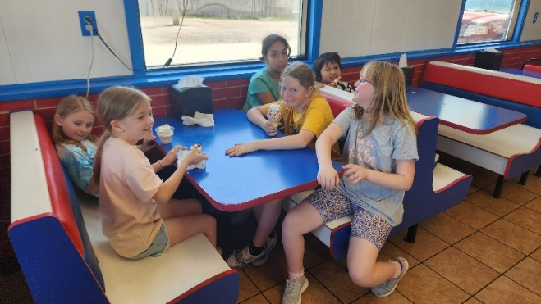

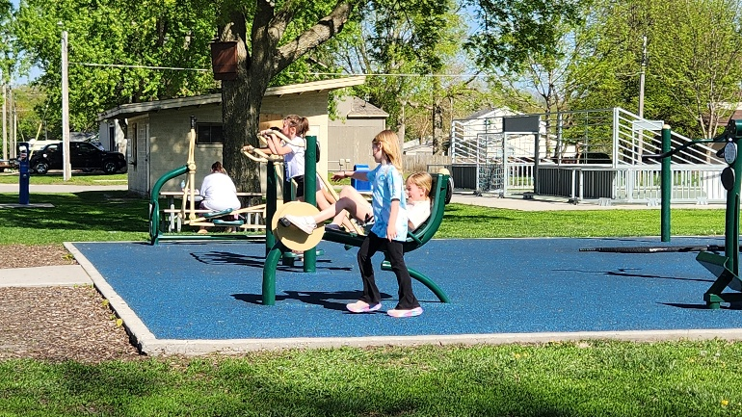

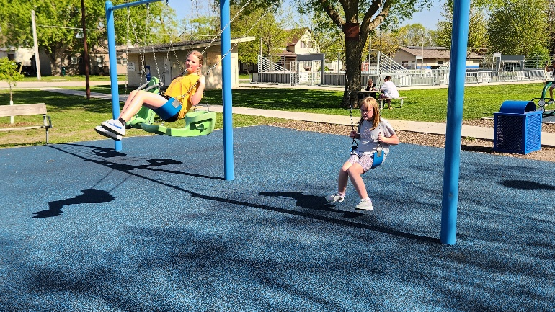

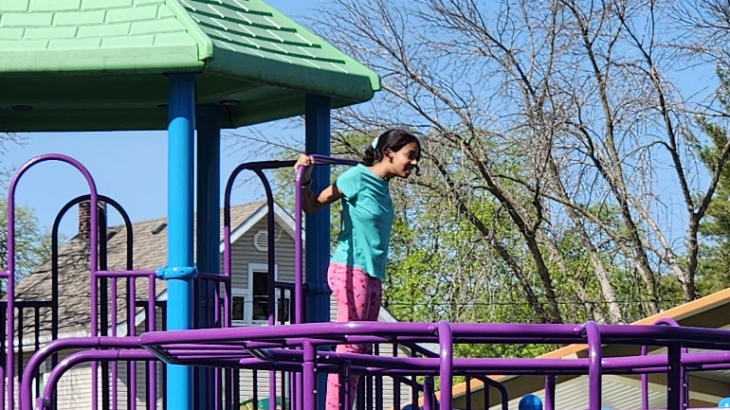

**Treasurer’s Report**

**INCOME April YEAR TO DATE**

Pledges and Offerings $28,043.10 $78,712.16

Other Income 0.00 .00

**TOTAL INCOME $28,043.10 $78,712.16**

**EXPENSES**

Outreach and Mission 1,250.00 $5,000.00

Pastoral Services 8,791.23 34,153.22

Maintenance and Repairs 1,578.56 10,878.22

Church Office 3,184.44 13,627.07

Music Ministry 500.00 2,300.00

Christian Education 0.00 55.64

Local Ministry 16.41 20.68

Misc. Expenses 39.70 757.55

**TOTAL EXPENSES $15,360.34 $66,792.38**

**Bell Tower Update from the Finance Board**  
Church members and friends:  
As you know, we amended our 2025 budget by $70,000. Reason was to increase the building fund budget to $104,000 to cover bell tower renovation and several other needed building repairs. As noted below, about half the budgeted amount ($49,000) has already been applied to the project; $38,500 cash is still available. Here’s what it looks like:

Building fund Assets (rounded)

Checking account $18,500  
Mutual fund money income from  
Johnson building fund and personal donations $20,000  
Total cash available $38,500  
  
Building fund budget (rounded) $104,000  
Amount used $49,000  
Net remaining $55,000  
Funds available $38,500  
Amount needed $16,500  
  
All remaining Johnson building fund assets are in bonds. The next one matures in November, 2027. We’d pay a hefty penalty to cash early. Last year interest income from the bonds and mutual fund was just over $12,000. This year, after cashing the mutual fund, it will be about $9,000.  
  
The Finance Board is appealing to you to help raise $30,000. That will cover the remaining bell tower cost and replenish building fund cash reserves. Please consider making an extra donation to support this project. Be sure to put “bell tower” on the notation line of your check, drop it in the offering box or mail it to the church office.  
  
A prayerful thank you for your support,  
Finance Board - Tracy Wehrhan, Dale Olson, Nate Lahr, Dalene Schlitter, Wil Groves

**First Congregational United Church of Christ**

**Cabinet Minutes April 8, 2025**

Cabinet Minutes May 13, 2025 Moderator Curt McCoskey called the May 13 Cabinet meeting to order at 7:02 pm with the following members in attendance: Dale Olson, Susan Meinders, Kolleen Taylor, Lorraine McCoskey, Patty Gescheidler, Tracy Wehrhan, Carol Crystal, Pastor Craig Blaufuss, and Gayle Olson. Pastor Craig offered a prayer to start our meeting. Minutes of the April meeting were approved as written on a motion by Kolleen Taylor and a second by Lorraine McCoskey. Motion passed. Treasurer’s Report Tracy reported April offerings were about $7,100 more than expenses thanks to the Woods endowment. He also reported Mr. Vesey has been paid for the repairs that have been completed on the NE corner of the building as well as for the down payment for bell tower repairs. Tracy moved to put the report to audit, Dale seconded. Motion passed. A question was asked what “being put to audit” meant. It was explained the report is filed and ready for an audit should the church decided to have one done. It was stated one had not been done for a few years, but with the expense of doing one it was felt with the church being a non-profit it really is not a big concern. Pastor’s Report: Pastor Craig shared updates including plans for our first Saturday summer worship service on June 28 and a potluck afterwards. He mentioned the need for groups to cover one week of the summer lunch program and the agreement with Good Life RV to sponsor the food for the first week in June in which our church is serving. He shared the ministerial association will be present at the first WC Market Night on May 29 sponsoring a dunk tank to raise money for the backpack program. Another workshop will be held on June 12 to learn how to put together a worship service. KLAB ended the year on May 6 with a trip to DQ and then fun at East Twin Park. Finance Board: Tracy shared that scholarship applications are due on June 16 and discussed the criteria for eligibility. Question was asked about criteria for scholarship applicants, and it was explained that applicants must have a connection to the church. Tracy also provided updates on the northeast corner completion and the elevator repair, noting that the conduit is rusted and needs replacement. Trustees: Kolleen discussed the need for an annual inspection to prevent issues from going unnoticed and ensure that maintenance issues are addressed promptly. She shared updates on the grounds, including the spraying of weeds and the planting of pots by Joyce and also mentioned the need for watering the newly filled holes and the ongoing efforts to keep the grounds in good condition. (thanks to Tom Riemenschneider for the dirt) The firewall is being built for the elevator by Mr. Vesey. It was noted there is still oil from the hydraulics leaking in the elevator shaft - Schumacher has been contacted. Mission Board: Susan reported the Brownie Sundae Drive-thru will be July 18. Appreciation day for the WC linemen will take place on May 20 when bars will be delivered to them by Susan & Steph. We serve summer lunch June 2,4, &6. We will be serving Hot dogs, Walking tacos, and Mac & Cheese with Ham sandwiches. A big thank for Good Life RV, & Patty G for asking, for sponsoring our week. Heifer Project has been mailed a check for $125.25 from our filled peace pipe. Disaster Relief pickle jar generated $327.00 which has been sent to UCC disaster relief fund. Women’s Fellowship: Thrift Sale $1800 before expenses. A big thanks for everyone’s help! May dinner will be Wednesday May 21 at 5:30. Everyone is welcome for this salad meal. Recipients of the $5,700 will be announced at this time and each Circle will share things they have done this year. Worship Board: Curt noted communion will be the second Sunday in June as that is Pentecost Sunday. Saturday worship services for the summer will be June 28, potluck to follow, July 26, and August 23, with root beer floats to follow worship. Mothers were gifted carnations on Mother’s Day. Fathers will be receiving a bag of snacks on Father’s Day. It has been requested that Melissa be asked to play the organ more frequently than is happening at the present. Worship Bd will look into this. Christian Education: A successful Easter breakfast was held with around 40 people being served. Old Business: None New Business: Search Committee had met earlier today, May 13. They are hoping to have a survey in the hands of church members by this weekend. They will be available to be picked up on Sunday, May18, and any not picked up will be mailed the following week. The deadline for returning these is June 2. A profile will be developed from these surveys and this is what will be used to find a new pastor. It is hoped by fall the profile will be being circulated by the Conference. Heritage Committee is not a standing committee and will be reinstated when the church has a milestone anniversary. Technology Committee - concerns in regards to tech will be addressed by those who volunteered for tech on our Find Your Niche sign-up. It was pointed out First -Aid kits need to be updated. Women’s Fellowship volunteered to take care of this and make sure there is a kit on each level of the church. The AED is currently getting its yearly check-up at the hospital. Next meeting will be June 10, 2025 at 7:00 pm. Meeting adjourned at 7:59 *Respectfully submitted Gayle Olson*

FIRST CONGREGATIONAL UNITED CHURCH OF CHRIST

**Address Service Requested**

God is still speaking

to everyone in the home of:

