April 2026 Newsletter
First Congregational United Church of Christ
1000 Willson Avenue - Webster City, Iowa 50595
515-832-2232
http://www.firstcongregationalwc.org/

“Jesus went on to say, ‘In a little while you will see me no more, and then after a little while you will see me.’” -John 16:16
“So with you: Now is your time of grief, but I will see you again and you will rejoice, and no one will take away your joy.” -John 16:22
When Jesus came out of the tomb on Easter day, he had about 40 days (according to the book of Acts) to say his goodbyes before he left this world again. I wonder if the 40 days were enough?
Now to be clear, the gospels record Jesus’ interactions with the disciples following his resurrection as being primarily exhortation and commission, not the sentimental saying of goodbyes. And yet it’s hard to imagine that there were no sentimental feelings involved in those final 40 days. While it is true that, in our vernacular, Jesus was “going to a better place”, what is also true is that he invested himself completely in his earth time, touching many lives, teaching, exhorting, and offering words of correction given with love. While we don’t necessarily get a picture from the gospels that Jesus formed many deep and lasting friendships in this life, it's hard to imagine that a person of such deep love and feeling did not form many intimate friendships and relationships… and saying goodbye is always hard when you know that time is short. I wonder if in those forty days he spent time remembering all the lives he had touched, the miraculous healings he had given, the many, many interactions he had with others for counsel, and even small talk. It does make you wonder if Jesus felt any sense of grief at the thought of leaving this world, and all the people he had touched.
Now I will admit that I am perhaps projecting a bit. The gospel of John claims that Jesus was the incarnation of the eternal Logos which created the world, so it's hard to imagine such lofty power could become so humanly sentimental. Add to that, Jesus’s resurrection may have powerfully reconnected him with the widest possible story of love and redemption working its way through history… and so from that perspective, human partings might seem very minor.
Yet Jesus was also the soul who wept at Lazarus’ grave, even though he knew he would soon be resurrected from the dead! So, yes-- it is possible that even on the far side of the resurrection, Jesus knew the grief of parting and saying goodbye.
And what has this to do with us, you may ask? We who are thoroughly human know the grief and sorrow of parting, whether it is only for a short time, or for the rest of our human lives. It also seems perfectly human to reflect on the past and all that has happened in our lives, and feel a sense of loss for much that what once was, and now is going...or gone. Grief in all of its forms is natural and inevitable in our human lives, and it is a human emotion that painfully speaks of our need for one another, and of our uneven grasp of time here on earth. And so to me it seems comforting in some sense that even Jesus felt the pain of parting and the grief of loss, which includes the loss of the past and all that once transpired.
And yet, if Jesus felt pain and grief as he prepared to leave this earth for the final time… those feelings were surely tempered by his cosmic understanding that nothing is ever lost. The good we have done, the love we have given and received, the precious moments of laughter and joy, and yes, even the moments of tears and struggle and heartbreak… all of these are embedded in our stories, and remain as eternal memories in our souls, which are eternal.
And the Gospel of John tells us that Jesus foreknew that he would be joined again with all those he had touched and known and loved…in the fullness of time!
This beautiful Good News is one of the blessings of Easter! The magnitude of the miracle is incomprehensible to our limited human minds, but Jesus foreknew there will be joyous reunions on the far side of grief and sorrow! And Jesus also knew that the daily grist of our earth lives will always be available to us…even as we continue to create new relationships, share new loves, and endlessly build new lives.
For all of us who are struggling with grief in all of its dimensions, all this is good news indeed! May this good news bring you peace and great hope, as we prepare for Easter: that great day of Good News, peace and hope! -- Pastor Craig

Church Staff

Rev. Craig Blaufuss, Pastor
Office: 832-2232 Cell 297-4316
Pastor’s email: revcraigblaufuss@gmail.com
Michele Omvig: Admin. Assist. 269-7210
Church’s e-mail: administrative.office@fcuccwc.org
Melissa Hindt: Organist 712-351-1074
Curt/Lorraine McCoskey: Cust’s. 515-297-0261
Tracy Wehrhan: Church Treasurer 297-0370
Dale Olson: Financial Secretary 839-5619

CHURCH OFFICE HOURS

M 8 am - 1 pm

T 9 am – 1 pm

W 8 am – 4:30 pm

Th 8 am – 4:30 pm

F 9 am – 1 pm

HAPPY BIRTHDAY TO:
2 - Karin Yungclas
4 - Sherry Leksell
9 - Wil Groves
9 - Lynn Leksell
12 - Mya MacRunnel
13 - Karla Krebs
15 - Lorraine McCoskey
16 - Jacob Lahr
17 - Alaina Imhoff
18 - Shelby Brim
19 - Christy Fiala
25 - Hailey Marie Brim
HAPPY ANNIVERSARY TO:
4 - Alan & Karin Yungclas
28 - James & Gretchen McGlynn


Thrift Sale, Spring 2026
It’s time to begin spring cleaning and collect your Thrift Sale donations. Be sure items are clean, in good repair, and free from smoke and pet hair. The date has been moved to Friday, April 17 & Saturday April 18th. Sign-up sheets will be out on the table mid-March to volunteer your time.

Maundy Thursday Evening Service April 2, 5 p.m.
We will observe Maundy Thursday with a service of worship beginning at 5 pm in the East Chapel. We will reflect together on the meaning of this night and share the sacrament of Holy Communion.

Easter Morning Breakfast
The Christian Ed Board invites you to Easter morning brunch, April 5th, at 9:00 am before morning worship. Everyone is welcome, so please plan to join us. A sign-up sheet will be on Fellowship Hall table so we might judge how much food is needed, but if you don’t sign up, you are still welcome. We always have enough. See you there in your best Easter outfit!!!!

Easter Flowers

The Chancel Committee invites you to share your favorite flowering plant with the congregation for the Easter service. We have had some lovely lilies, daffodils, azaleas, hyacinths and tulips in recent years. If you wish to participate, please have your flower(s) at the church by 4pm on Sat., April 4. You may take your flowers with you following the Easter service, Sun., April 5. If your flowers are in honor or memory of someone, get that information to Michele in church office by Wednesday, April 1.

Easter Activities Sunday, April 5
Easter is the pinnacle of the Christian faith, the day of our greatest celebration as Jesus “conquers sin and death and reconciles the world to himself.” Join us as we begin our Easter celebration at First Congregational with a festive Easter Breakfast, starting at 9:00 a.m. in Fellowship Hall, provided by the Christian Education board. There will be a free-will offering that will benefit our Christian Education program. There will be no Adult Education class that day. At 10:30 a.m. we will gather in the sanctuary for our Easter Worship service, which will include the sacrament of Holy Communion. There will be no coffee after worship that day.

Shalom Circle Continues
The Shalom Circle continues to gather weekly whenever possible, usually on Fridays beginning at 6:30 p.m. Join us in East Chapel as we experience Shalom through prayer, meditation and silence!

The search for pastoral leadership continues. We maintain contact with associate conference minister Kendy Miller. While there appears to be no prospects for a full-time pastor at present, she says she does have a possible interim candidate who has inquired about Webster City. That person has to meet with the Conference Committee on Authorized Ministry before Kendy can connect her to us. She expects that to be done by mid-summer. Then we would be able to go through the interview process and decide if our interests and hers coincide.

Meanwhile, pastor Craig has altered his retirement plans and will continue on a 3/4 time basis from June 1 until the end of the year and perhaps beyond if we have not found pastoral leadership. He will step down if we do find someone to fill that role.

Retirement Party Thank You
I cannot tell you how much Vicki and I were touched by my retirement party on March 14! The planning committee worked very hard to make a very memorable day for us, and you succeeded! Curt McCoskey was his usual witty and charming self as the MC of the event, and listening to the remarks of the speakers was both humbling and gratifying. The refreshments were wonderful, and it was such a blessing to visit with all the guests from the community as well as our church! Vicki and I cannot thank you enough for such a wonderful day! –Pastor Craig
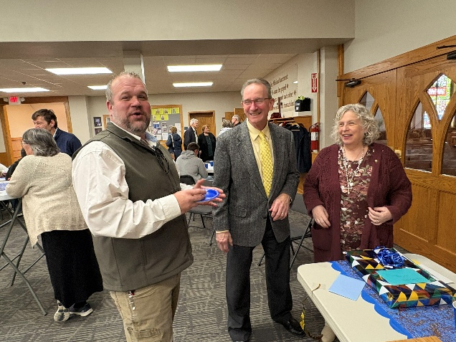
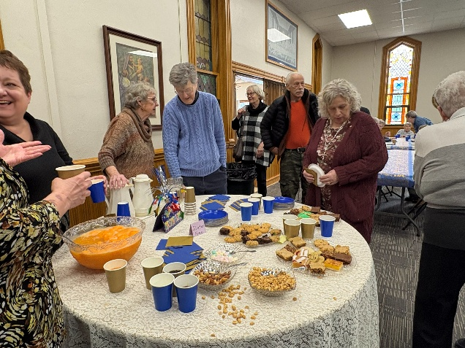
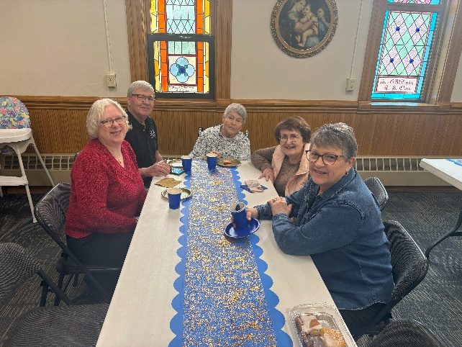
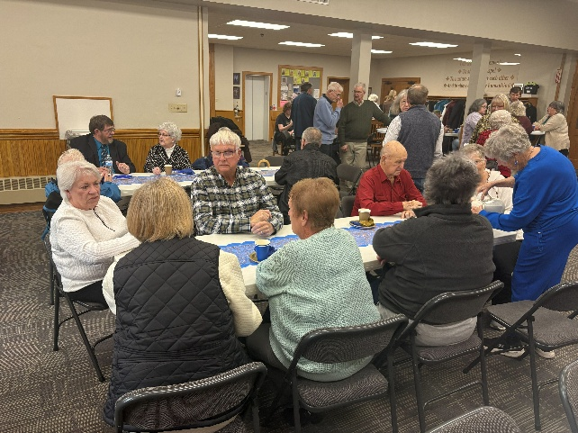
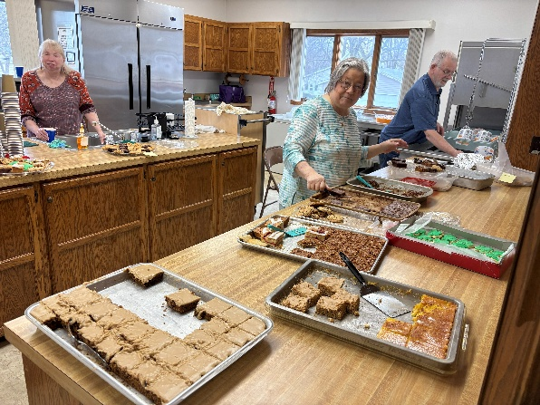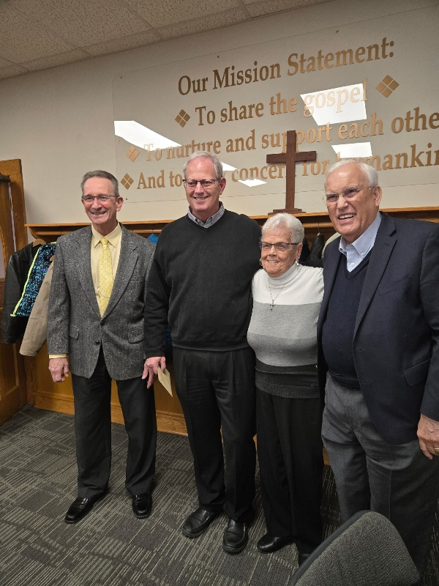
Earth Day
Earth Day 2026 is Wednesday April 22. Mission Board is still hoping to have a project for folks to be a part of and there will be more information to come. But to help you start thinking about why we have an Earth Day (shouldn't everyday should be considered Earth Day since it is God’s creation for us to care for?) here are a couple of questions for you as you think about some of our daily habits and maybe ways you can change them for the good of all.
WHAT ARE MICROPLASTICS?
A. Really small plastic toys
B. 100ml plastic bottles
C. Plastic particles which carry chemicals
D. Plastic straws cut into small pieces
When plastic waste is dumped in the ocean, ocean waves break down plastic into particles known as microplastics. Microplastics float around the environment, carrying endocrine disrupting chemicals, such as flame retardants and biocides, so if you answered C, you were correct.
HOW DO TOXIC CHEMICALS DISPERSE
A. Inhalation
B. Ingestion
C. Direct skin contact
D. All of the above
When microplastics enter the environment, they are dispersed into water, food, daily life
products, plastic-based medical supplies, and float as airborne plastic pollution. When we eat, drink, and breathe, humans unknowingly
ingest and inhale toxic chemicals, which have
detrimental impacts at the cellular level. If you thought the answer was all of the above, you
would be right.
If you would like more quizzes and information, one site to access is earthday.org

Pecans
We still have pecans for sale at $13 a bag. They are in the chest freezer.

Thanks
Ed and I would like to thank our Church family for all the thoughts, and prayers during our recent health issues, and now during our recovery. We are thankful, and grateful for you remembering us in your prayers.
Andrea and Ed Mosbach

Treasurer’s Report

INCOME February YEAR TO DATE
Pledges and Offerings $16,758.47 $33,428.28
Other Income 703.09 703.09
TOTAL INCOME $17,461.56 $34,131.37
EXPENSES
Outreach and Mission 1,250.00 $2,500.00
Pastoral Services 9,371.50 17,760.31
Maintenance and Repairs 2,278.06 4,773.71
Church Office 3,586.67 7,009.80
Music Ministry 550.00 1,100.00
Christian Education 0.00 0.00
Local Ministry 0.00 0.00
Misc. Expenses 8.99 327.68
TOTAL EXPENSES $17,045.22 $33,471.50

FIRST CONGREGATIONAL UNITED CHURCH OF CHRIST
Webster City, Iowa
Cabinet Meeting held on March 10, 2026
Members Present:
Moderator: Patty Gescheidler Christian Ed: Glenda Wehrhan
Vice Moderator: Dale Olson Trustees:
Finance Sec.: Dale Olson Women’s Fellowship: Patty Gescheidler
Treasurer: Tracy Wehrhan Pastor: Craig Blaufuss
Mission: Gayle Olson Worship: Marjorie Groves
Staff/Parish: Stephanie Hill Clerk: Stephanie Hill
The meeting was called to order at 7:06pm by Moderator Patty Gescheidler. A prayer was offered by Pastor Craig. The minutes of the February cabinet meeting were read. Tracy Wehrhan moved and Gayle Olson seconded a motion to approve the minutes. Motion carried unanimously. Treasurer’s Report: The February expenses exceeded offerings by $500.00. The Margie Wood Endowment was received. The checking account is being moved to a higher interest account. Tracy Wehrhan moved and Cindy Henning seconded a motion to put the report to audit. The motion passed. Pastor’s Report: Pastor Craig appreciated the folks who gave the services during his absence. Care Center services were covered by Patrick Wiedemeier on February 15. He will officiate at the Celebration of Life for Leo Turner on July 18. Christian Ed class on Lent was led by Dale Olson. Finance: The Board members have not met. The members are waiting for a recommendation from the Trustees regarding the audit. They plan to meet in May for scholarships. Mission: The Beacon of Hope meal is scheduled for March 23rd. The sign-up sheets are on the table in Fellowship Hall. For the annual DSAOC auction, Mission members will meet after service on March 15 to assemble the basket(s). The 5 special offerings were discussed. OGHS is March 22; Neighbors in Need is October 5th; Strengthening the Church is June 8; and the Christmas Fund is December 24. Kendall Young Library will be the recipient of Appreciation Day. May baskets are planned for shut-ins. And Earth Day will be celebrated on April 22. Women’s Fellowship: The Thrift Sale dates were changed to April 17 and 18. A sign-up sheet will be in Fellowship Hall on April 1st. Providence Circle will host the Iowa Community Theater Association conference meal on Saturday, March 28. Haystack and Plymouth circles were asked to provide workers and bars. The Lenten Luncheon is Friday, March 27 at noon at Briggs Woods. The cost is $15.00 and the menu includes a gluten-free option. The speaker is Sarah Namukose from Asbury United Methodist Church. Worship: The Maundy Thursday service will be April 2 at 5pm. The Easter Sunday service will begin at 10:30 instead of 10:00 allowing more time to enjoy our Easter breakfast and so that Josi Greenley, who will accompany us, can get here in time. Christian Education: KLAB met on February 18 to celebrate Valentine’s Day with snacks, a devotion, and games. Get Well cards for Pastor Craig were created. Adult Sunday School will be held with the help of Patty Gescheidler, Dale Olson, Cindy Henning and others. A discussion about leading and topics was held. We have 2 graduates from high school this year, Lucy Midtling and Haley Brim. More information will be coming. Search Committee: There are no new candidates. Staff/Parish: The members met March 1st after service to elect officers and staff advisors and review some procedures. Trustees: No representative present. Stephanie Hill moved that the Board reports be approved. Dale Olson seconded the motion. The motion carried. Meeting was adjourned at 7:37pm.
FULL BOARDS AND COMMITTEE REPORTS:
Mission minutes $293.00 from the pickle jar, and $250.00 from January mission funds, put together for total of $543.00, and donated to ACE. $250.00 February mission. Gayle took Alternate Giving auction money to District office to be distributed among the schools for teachers to use for student needs. —Soup lunch - went very well. —Beacon of Hope meal - January meal. We were unable to host the meal, due to snow blizzard, however the casseroles were taken over earlier in the day and baked. Residents were able to enjoy the main dish. A March meal will be scheduled. —14 “meals in bag” received 14 complete meals and taken to UDMO. —March 26 – D/SAOC - auction. Decision to make a “Baking basket” theme. Discussion from this past Sunday, we may opt in making several baskets, a poster will be on display, with ideas for donated items. The basket(s) are due March 15.
Cabinet members for the 2026 year: Chair - Sherry Leksell Cabinet representative - Gayle Olson
Secretary - Andrea Mosbach
Women’s Fellowship Executive Board Minutes Cards – Carol Crystal is doing a wonderful job, however, I have told her that we will only send cards for special milestone b-days, anniversaries, occasions like births, deaths, hospitalizations, get well wishes. So, if you hear of someone in need of a special wish, drop Carol a text, email, or call to let her know. Thrift Sale - Cindy will be gone during the scheduled sale dates, so we would like to change the date of the spring thrift sale to April 17 & 18. We have been selling items on the buy and sell page on Facebook. This year we want to express the need to have only clean and pet hair free clothing. There are many who have allergies and we do not want to make them worse. It looks better too. WCCT Meal for March 28, will be hosted by Providence Circle. We have chosen the following Menu: Ham Balls, cheesy potatoes, peas & carrots & roll. We will serve lemonade, water & coffee. We are asking the following from Plymouth and Haystack circles.
2 pans to church by Friday, March 27 Lenten Lunch, 2026 Host Church – Church of Christ Friday, March 27, 12 – 1 pm Location: Briggs Woods – Cost $15.00 Menu - stuffed chicken breast
(Gluten free/Catholic option available – salmon on rice) parsley buttered baby red potatoes, house salad, green bean almondine, roll, water, lemonade, Andee’s mint for dessert on tables
Reservations – begin Feb 23 – March, prepayment due at your church by March 10. Program: Pastor Sarah at Asbury. Pastor Craig Retirement Open House – Saturday, March 14 @ 2 pm. Women’s Fellowship has been asked to serve cookies & bars, water, coffee, sherbert punch. Gayle and Cindy will get paper plates and napkins and cups for punch and coffee. We can ask committee about nuts and mints.
Christian Education Minutes Chair—Cindy; Secretary—Glenda; Cabinet Rep--Lorraine
KLAB met on February 18. We had snacks, devotion, games as we celebrated Valentines Day and made Valentine-Get Well Cards for Pastor Craig. Fun was had by all! Discussion on the Klab Program and it’s future after Pastor Craig’s retirement. Can we continue and, with the help of the church family, make it successful? ADULT EDUCATION Discussed the continuation of Adult Sunday School and who would be the leader. Taking turns being the leader and organizing a topic. The idea will be presented to the class, and they can have a discussion on that or come up with ideas for an alternative plan. OTHER BUSINESS Discussed graduates we have for 2026. More to be announced as it gets closer to May. Christian Education serves the Easter Breakfast that will be held on April 5th at 9:00 before church worship at 10:00. More to be announced. Next Meeting: March 5th at 9:00 am at the church
Staff Parish Board January, 2026 through December 2026 Staff Parish Members: Chairman—Stephanie Hill Cabinet Representative—Ann Latham Secretary—Sharon Perry Staff Advisors— Kolleen Taylor & Tom Riemenschneider (Staff Advisors will contact each staff person and find out who the Staff Person Wants to be their Staff Parish Liaison. Each match will meet privately
to discuss any issues that need to be considered.) The Staff Parish Board will meet as needed or approximately 4 times per year.
Pastor’s Cabinet Report My Absence: This won’t be much of a report since I have been absent from duties since January 28 when I checked myself into the ER at Van Diest Medical Center for terrible abdominal pain. Since then I spent 13 days in the hospital, finally being released February 11, and then I spent 2 weeks recuperating at home. February 24 I returned to duty part time as I continued to recover, and I did lead adult ed and worship on March 1. I cannot thank everyone enough for their patience and prayers as I have been recovering. And I am grateful that I continue to build up strength so I can fully resume all duties as your pastor! Worship: The four Sundays in February were led in worship by members of our church: Feb. 1, Marjorie Groves; Feb. 8, Cindy Henning; Feb. 15, Wil Groves; Feb. 22, Gretchen McGlynn. We are all grateful for their willingness to step up and prepare and lead worship! I did lead worship March 1, and we shared the sacrament of Holy Communion. We were scheduled to lead care center worship services on Feb. 15, but we could not so Patrick Wiedemeier led those services in our place. We did not hold our traditional Shrove Tuesday Pancake Supper or our Ash Wednesday Worship service on Feb. 18 due to my absence. Funerals: I have been contacted about officiating at a Celebration of Life for Leo Turner on July 18. It will be held at the American Legion. CE Programming: In the last week of my absence the class met to discuss Lent, with Dale Olson facilitating the discussion. Upon my return Adult Education has re-started a study of “Artificial Intelligence” (AI). KLAB has had some cancellations, but they did have their Valentine’s Day party on Feb. 11 and they met again on Feb. 25 to make posters for the UCC annual Climate Change Art Contest. Thanks to Cindy Henning, Glenda Wehrhan, Lorraine McCoskey, and Susan Meinders for running the program! I resumed leading on March 4, and we learned about Lent. Northwest Association: There has been no announcement about any planned Association meeting in the Spring of this year. Shalom Circle: After a long hiatus we reconvened March 6 in East Chapel.
Worship Board We selected Worship Board officers, with Gretchen and Don as co-chairs, Jane as secretary, Cindy preparing communion, and Marjorie as Cabinet representative. The Maundy Thursday service will be April 2, 5 p.m. The Easter service begins at 10:30 a.m. to allow accompanist Josi Greenley time to get to our church and to give extra time for the church-hosted breakfast. We are delighted to have Pastor Craig back in the pulpit but also want to be prepared with lay led worship services in case they are needed and as the congregation seeks a new minister. We know of five church members who are preparing worship services and would welcome more. Don returns to Iowa the week of March 8; Jane returns to the United States March 29.
Mission Minutes Old business: —Beacon of Hope meal, March 23 —DSAOC auction - Baking basket. After church March 15, committee will meet to prepare the baskets, (2 or 3). Gayle will then deliver the basket for auction by March 26th. New business: —Special offerings One Great Hour of Sharing- March 22, Gayle Neighbors in Need-October 5, Sherry Strengthening the Church-June 8, Stephanie Christmas Fund-December 24 offering OCWM-donation come from budget —Appreciation Day-we chose the Library. Treats, “grab and go”. Approximately 15 employees and volunteers. Will pick a day in April’s meeting, and be thinking of what snack you would like to bring. —May baskets for shuts in’s. Snack mix, Rice Crispy bars, caramel puff corn, etc. Andrea will ask Pastor if KLAB could make the bags for the project, as they did last year. Will pick date for KLAB project, Andrea will bring items for bag decoration. —Earth Day. April 22. Gayle will look into projects, can always clean up an area around town. Next meeting - April 7, Tuesday, at 5pm.
Staff Parish Board The Staff Parish Board met after church to get their organizational meeting done. The paid staff were asked to choose their Staff-Parish partner for this year. Pastor Craig chose Ann Latham. Curt McCoskey picked Tom Riemenschneider. Michele Omvig wanted Stephanie Hill. Melissa Hindt preferred Kolleen Taylor. The Staff Parish Board was very happy with paid staff picking their partner for this year. Confidentially was emphasized and all issues that need consultation will be kept private. The only statement we will make is: “We had an issue---it has been resolved.”
Christian Education Minutes Chair—Cindy Secretary—Glenda Cabinet Rep--Lorraine
KLAB The Klab program will be led by the members of the Christian Ed. board so Pastor Craig can continue his journey to recover his strength. The last day of Klab will be April 29 with our trek to the Dairy Queen and east Twin Park. Pastor Craig will join us for this tradition! The board will meet this summer to discuss the Klab future this fall. Discussed having Confirmation class this fall, being led by Curt McCoskey with the guidance of Pastor Craig. (All will be discussed further depending on our search for a new Minister.) ADULT EDUCATION Adult Sunday School will continue with volunteers from class providing topics and leading the discussion. OTHER BUSINESS Christian Education serves the Easter Breakfast that will be held on April 5th at 9:00 before church worship at 10:30. Sign up sheet is in Fellowship Hall. Graduation Recognition will be May 10th. It is also Mother’s Day Recognition. Next Meeting: April 2nd at 9:00 am at the church

FIRST CONGREGATIONAL UNITED CHURCH OF CHRIST

Address Service Requested

God is still speaking
to everyone in the home of:



