June 2026 Newsletter
First Congregational United Church of Christ
1000 Willson Avenue - Webster City, Iowa 50595
515-832-2232
http://www.firstcongregationalwc.org/

“What if some were unfaithful? Will their faithlessness nullify the faithfulness of God?”--Romans 3:3
“Therefore encourage one another and build each other up, just as in fact you are doing.” –1 Thess. 5:11
Have you ever “lost faith?”
I recently met someone who was trying to recover her “lost faith” -- in just about everything! She lost faith in her family life with the death of her mother and the incarceration of her father. She lost faith in herself when she went rogue and was ultimately jailed. She lost faith in the foster care system when her young daughter was placed in it, only to endure emotional abuse by her foster parents. She lost faith in the church, and she turned her back on it. Ultimately, she lost faith in God, and Life, for all that had happened to her. When I met her, she was planning to move back to her home state to try to reset her life and find some peace and direction. Hearing her story, I must admit that if I were her, I might well have lost faith, too! Hearing her story, I wonder if you have ever gone through trials and hardships in your life that made you lose faith?
Now losing faith is more than just being disappointed. Losing faith is more than just having unanswered questions, or realizing that the “answers” you once felt were solid as a rock now feel like sand. To really lose faith is unlike any other loss; it shakes you to your core, leaves you broken in spirit and wondering if life has any meaning, purpose, or joy left for you to experience. It is profoundly disorienting and leaves you vulnerable and at a loss for what to do next. It is, in a nutshell, like finding yourself in a dark place without hope of ever seeing the light again.
In times of crisis and trial, losing faith is understandable. But when you have lost faith, what are you to do? Pray anyway? Put on a sunny face and pretend all is well? Become destructive toward others, or toward yourself? Numb yourself? End…yourself? Try to heal…yourself?
To my mind so much of the sorrow, rage, and dysfunction we see in the world today is at heart a crisis of lost faith: not just a lost faith in a “God,” but in other humans, in human institutions, in our own selves, and in the workings of Life which can feel unfair, capricious, and utterly oblivious to goodness, tenderness, compassion and justice. In the face of such lost faith, what can offer healing and hope? What can help people find faith again?
Jesus knew what could help people find faith again—HE could! While Jesus taught many things, it was his presence that brought many people back to faith, time and time again. This miracle was possible because Jesus showed them what they needed to see: a human being who revealed the presence of God (remember Emmanuel, “God with Us?”), and offered them unconditional love, assurance, peace, and a presence so grounded and at one with Life that they could dare believe again in the goodness of Life. His presence was like a high vibration that flowed from him, flowing into the minds and hearts of people who needed a new vision/vibration that restored what they most yearned for: faith in God again, faith in Life again, faith in other people again, and faith in themselves again. Seeing him, feeling him, sharing in his miraculous Knowing…they could experience a reset that led to faith again!
And while we will not be able to fully manifest the presence of God, as Jesus did…and while we may not be able to fully manifest his unshakeable faith, his peace, and his love for all people…we, as his disciples, can still offer our presence to those who have lost faith! We can listen with love, be slow to judge, let them sense our peace, and most importantly, let them feel our love! For as I have heard throughout my life, faith is “caught,” more so than “taught” …and what a blessing it would be to have someone in despair find faith again—through you!
To return to my encounter with the woman who had lost faith, I have no idea if I will see her again, or if her relocation will be the reset she needs to restore her faith in so many things. I have no idea if I, and the others who were with her who showed her genuine love and concern, will help her believe in human beings—and in herself—again. But to have faith also means that we do what we can to help whoever we can, trusting that God will work all things for good—including a short encounter with a stranger who is struggling with life. I pray that we all realize how important our faithful presence is to our families, our church, and our community, and I pray that in our day-to-day interactions with others, they will sense our goodwill, feel our love, and know that we have faith! –Pastor Craig

Church Staff

Rev. Craig Blaufuss, Pastor
Office: 832-2232 Cell 297-4316
Pastor’s email: revcraigblaufuss@gmail.com
Michele Omvig: Admin. Assist. 269-7210
Church’s e-mail: administrative.office@fcuccwc.org
Melissa Hindt: Organist 712-351-1074
Curt/Lorraine McCoskey: Cust’s. 515-297-0261
Tracy Wehrhan: Church Treasurer 297-0370
Dale Olson: Financial Secretary 839-5619

CHURCH OFFICE HOURS

M 8 am - 1 pm

T 9 am – 1 pm

W 8 am – 4:30 pm

Th 8 am – 4:30 pm

F 9 am – 1 pm

HAPPY BIRTHDAY TO:
4 - Virginia Veach
8 - Connor Clements
9 - Stacy Wearda
9 - London Clements
13 - Dalene Schlitter
14 - Amanda Lahr
14 - Zachary Lahr
14 - Livia Oberender
15 - Alexis Byrne
18 - Chesney Fuller
19 - Wilma Reinsel
30 - Katie McCarville

Rev. Kendy Miller, our Associate Conference Minister, will be with us May 31 to help lead worship, offer the message, and listen to our questions and concerns regarding our search for a new pastor. Following the worship service we will remain in the sanctuary for a Q and A session, and after that we will enjoy refreshments with her in Fellowship Hall. Everyone is encouraged to attend and share your questions with Kendy!

Save the Date

The Mission Board is inviting you to a “Brownie Sundae Drive-Thru” to be held Friday, June 12 from 6:30 pm--8 pm. As we have done in the past, to enjoy a brownie sundae simply pull up in your vehicle to our West Entrance on Willson Avenue, tell the attendant how many brownie sundaes you would like, and the attendant will bring your prepared brownie sundaes to your vehicle. The Pickle Jar will be used to receive your free will donation. The Mission Board is requesting donations of brownies and ice cream. The sign-up sheets are in Fellowship Hall.

June 27 Puzzle
We'll have some sweet, some tart, a lot of variety, homegrown or imported, brand-new or originating generations ago, good-looking or a bit ordinary, downright practical or happy. Is this our congregation - or the potluck scheduled for Saturday, June 27, after the 5 p.m. worship service? Both! The Worship Board invites you to our annual summer event. The sign-up sheet will be on the table outside Pastor Craig's office. The Worship Board will supply lemonade and water. Please bring your own table setting - plate, glass, fork, and the like.

Scholarships
Applications are due to the office by June 15.

The Search Committee
We met via phone with conference minister Kendy Miller recently for an update of our current pastoral search progress. Her message: nothing yet but don’t lose faith.
Paul offered the same thought in Philippians 4:6-7:
“Do not be anxious about anything but in every situation by prayer and petition, with thanksgiving, present your requests to God. And the peace of God…will guard your hearts and your minds in Christ Jesus.”
So, with that in mind, the search committee asks you to add this to your daily prayers. Tape it to your bathroom mirror or other place for easy reference:
“Heavenly Father: Please guide our search for pastoral leadership that we may continue the good works of this church in our community and world. We ask it in your name, Amen.”

Adult Education Class Continues
Our Adult Education class will continue to meet over the summer at the usual time: 9 a.m. We are currently focusing on the topic of “Salvation” in the Christian faith and in world religions! Join us!

Niche Group Update
When the Task Force formed Niche Groups in 2024, we asked volunteers to make a one-year commitment to one of the five “niche groups” we created. That year has become two. Much has been accomplished and we thank all who have contributed their efforts to make it so. But we need to keep these groups active as we move forward in our pastoral search. The Task Force now asks that you “review and renew” that commitment.
This is also a plea to those who were not part of the niche group to join us now. Here is a list of the niche groups and the responsibilities of each. Please review these opportunities. Prayerfully consider adding your name to one or more of the groups that fit your interests and abilities. Note that each numbered item is a separate group under the main heading.
Worship Team: Need at least 4, working closely with the worship board.
1. Create Sunday worship services; finding/creating liturgy, selecting hymns, finding online sermons either video or written.
2. Open and close the building on Sunday, check heat, lights, fans, mics.
Creative Team: Need several, working with Christian Education board.
1.Plan and oversee Adult Education.
2.Plan and oversee Klab program activities.
3. Plan and oversee shalom circle.
Pastoral Care Team:
1. Visit our care center residents and those hospitalized.
2.Make phone calls to check on those sick and those undergoing treatments.
3. Visit homebound members.
4. Visit those who have experienced a death.
Administrative team:
1. Proof bulletins and newsletters.
2. Learn to use the one call system and make calls as needed.
3. Post church events and information on social media/Facebook.
Tech Support Team:
1. Work with Pastor Craig to learn sanctuary projectors, take down, ship for repairs and reinstall.
2. Work with Michele to install Power Point files on sanctuary computers.

Graduation Sunday
Graduation Sunday was observed Sunday, May 10th. Those graduates able to attend were:
Hailey Brim, daughter of Jennifer and Mark Brim, and granddaughter of Elaine and Larry Brim, is a 2026 Webster City High School graduate. Hailey plans to attend Iowa State University after graduation and major in Interior Design.
Cael Alexander, son of Robin Myers and Thomas Alexander, and grandson of Ann Latham, is a 2026 Webster City High School graduate. He plans to attend Iowa Central Community College to pursue a degree as an electrician. He has always been interested in working with his hands. Becoming an electrician is a path that fits those interests perfectly. Cael’s older brother is already an electrician. Seeing his success and the work he does has inspired Cael to follow in his footsteps. He looks up to him and wants to build a similar career for himself. By attending Iowa Central and gaining the right education he is confident that he can reach his goals to become a successful electrician.
Graduates unable to attend were:
Lucy Midtling is the daughter of Kelly Midtling, and granddaughter of Tom and the late Holly Reimenschneider. Lucy is a senior from Saint Edmond Catholic School in Fort Dodge. She is currently graduating high school with an AA from Iowa Central and will further her education this fall at Iowa State University. At Iowa State, she will major in Human Development and Family Studies. After her bachelors, she will go on to get a Masters in school counseling to become a school counselor. Since she will have her AA, she will be able to have all of her education done in 2-4 years instead of going for 5 or 7 years of college.
Brandon Lahr is the son of Nate & Linda Lahr and grandson of Bud & Carol Crystal and Glenda & Tracy Wehrhan. He has graduated from Kirkwood Community College with a degree in Turf Management. He started a job with Iowa Sports Turf out of Ankeny on April 13th. They focus on athletic field construction. He is currently working in Dysart at the Field of Dreams, as they are building a large baseball and softball complex.
Sherry Leksell is graduating from Drake University's College of Education with a PhD in Educational Leadership. She plans to defend her dissertation in July.
Congratulations to all our Graduates.

Shalom Circle Continues
We will continue the Shalom Circle over the summer months, typically meeting on Thursdays or Fridays beginning at 6:30 p.m. in the East Chapel. Join us for an hour of meditation to music and voice!

On Sunday May 17th the Women's Fellowship presented checks totaling $5,300 to various organizations. Well done, ladies!
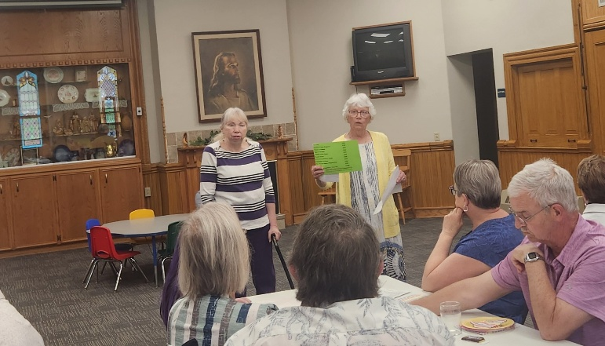
Jim Vesey, with help from his assistant Connor Omvig, recently completed the belltower tuckpointing and the belltower attic stabilization work.


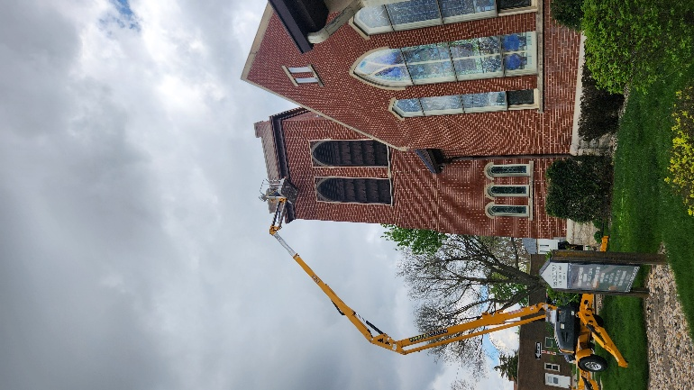

The last day of KLAB coincided with Earth Day (April 22), so after enjoying Dairy Queen treats our KLAB kids did a trash pickup along the railroad tracks at River Street all the way to the retention pond at Riverview Park.
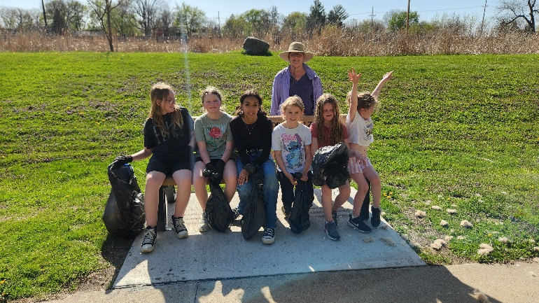

Treasurer’s Report

INCOME April YEAR TO DATE
Pledges and Offerings $16,508.00 $90,186.54
Other Income 0.00 703.09
TOTAL INCOME $16,508.00 $90,889.63
EXPENSES
Outreach and Mission 1,250.00 $5,000.00
Pastoral Services 8,152.20 32,844.93
Maintenance and Repairs 4,180.76 17,817.07
Church Office 3,280.13 13,471.40
Music Ministry 400.00 2,150.00
Christian Education 0.00 0.00
Local Ministry 0.00 0.00
Misc. Expenses 8.99 623.54
TOTAL EXPENSES $17,263.09 $71,906.94

FIRST CONGREGATIONAL UNITED CHURCH OF CHRIST
Webster City, Iowa
Cabinet Meeting held on May 12, 2026
Members Present:
Moderator: Patty Gescheidler Christian Ed: Cindy Henning
Vice Moderator: Dale Olson Trustees: Joyce Gelhaus
Finance Sec.: Dale Olson Women’s Fellowship: Cindy Henning
Treasurer: Tracy Wehrhan Pastor: Craig Blaufuss
Mission: Gayle Olson Worship: Marjorie Groves
Staff/Parish: Ann Latham Clerk: Stephanie Hill
The meeting was called to order at 7:00pm by Moderator Patty Gescheidler. A prayer was offered by Pastor Craig. The minutes of the April cabinet meeting were read. Gayle Olson moved and Tracy Wehrhan seconded a motion to approve the minutes. Motion carried unanimously. Treasurer’s Report: April offerings exceeded expenses by $1,000.00. Income and expenses are in line with expected percentages. Tracy Wehrhan moved and Dale Olson seconded a motion to put the report to audit. The motion passed. Pastor’s Report: On May 3rd, Clark and Jean Mowry performed a lovely duet for service. Hailey Brim and Cael Alexander were honored on May 10, Graduation Sunday. Thank you to Laurie Epps and the Christian Ed Board for the reception held after service. And as it was Mother’s Day, all women were given a carnation. On July 16th the Ministerial Association members will be at Market Night to fundraise. More information will be forthcoming. The Northwest Association held their Spring Association meeting in Belmond UCC on April 25th. They voted to donate $7,777 to the Iowa Conference. The Trinity Lutheran Church Food Pantry will not be moving to the old County Health Building. Adult education will meet over the summer. The Safe Church Policy committee will need to do background checks. Finance: has not met. The notice for Scholarship applications is to go out. The deadline for applying is June 15th. Mission: For Earth Day the KLAB kids along with a few adults picked up trash along the trail. May baskets were delivered to about 20 members. The Kendall Young Library staff was treated to snacks on May 6 for Appreciation Day. The Summer Lunch Program menu and grocery list with prices for the 3 meals totaled $300.00. This cost is now covered by a gift from Women’s Fellowship of $300.00. Mission Board members will host coffee on May 31st when Kendy Miller visits. The Brownie Sundae Drive-thru is June 12th. A sign-up sheet is out in Fellowship Hall. A project coming this fall will involve taking donations to purchase tokens for those in need of rides to medical appointments within Webster City. Women’s Fellowship: The Thrift Sale held in April netted $2,000. The program yearbook is being planned and the Funeral Committee will update its procedures. The May distributions were announced on May 17th. Please see the full report for more detail. Worship: A potluck is planned for June 27. Pastor Craig discussed items that need to be done in case of his absence. Two persons should know the ‘One Call Now’ system. The decision about blessing Communion will need to be made. Training on the ear microphone needs done for more than one person. And the protocol for calling off the service needs adjusted. See the full report. Christian Education: Please see the full report. Staff/Parish: Next meeting is May 31st. Trustees: Work continues on the bell tower, however, a gasket on the lift blew out so Jim Vesey is working on other things until it is repaired. Orkin is working on the holes that allowed bats in using their very heavy lift which caused sidewalk damage. Nick Blaufuss has been mowing, but the mower has only 1 height. Marjorie Groves moved that the Board reports be approved. Stephanie Hill seconded the motion. The motion carried. Search Committee: There are no new candidates yet.
The meeting was adjourned at 8:00pm.
FULL BOARDS AND COMMITTEE REPORTS:
Pastor’s Cabinet Report Worship: We enjoyed having Clark and Jean Mowry with us in worship on May 3, offering their musical gifts! May 10 we observed Graduation Sunday, honoring Hailey Brim and Cael Alexander. Following worship, we held a reception in their honor. Laurie Epps of the Christian Ed Board was in charge of the event! We also honored Mothers, since it was Mother’s Day. May 17th The Women’s Fellowship will host the coffee and tell us how they are distributing their raised funds in the community and beyond! May 31 the Mission Board will host the coffee after worship, and they will put out the pickle jar to raise funds to pay for our week serving meals for the summer lunch program. CE Programming: KLAB ended for the summer on April 29 with a trip to the DQ and then trash pickup along the River Street Railroad tracks. Adult Ed continues to study “Salvations(s)”. We will continue to meet over the summer. Thrift Sale: we had another fantastic Thrift Sale April 17 and 18, with much merchandise moved out of the building! We were also blessed to have young people from WCHS come and help haul items from the basement and then return to help pack items away and carry them downstairs! Summer Lunch Program: First Congo will serve meals at West Twin Park for the Summer Lunch program on June 15,17,19 (Mon, Wed, Fri) from 11:30 am-1 pm. The Mission Board will take charge of the meals, volunteers are welcome to help! Brownie Sundae Drive-Thru: will be held Friday, June 12, 6:30-8 pm. The Mission Board is directing this fundraiser. WCMA: will be downtown for the July 16 market nights attempting some sort of fundraiser.
Northwest Association: The Spring Association meeting was held at Belmond UCC on Saturday, April 25. We elected Rev. Bret Myers to be the Moderator, and Linda Tewes to be Vice Moderator. We voted to donate $7,777 to the Iowa Conference, from the Association’s savings. We heard a proposal to combine the Committee on Ministries of several Associations into one committee, that will likely be voted on at an Association meeting in the not-too-distant future. The next Association meeting will be held at Hartley in April 2027, date TBD. In other news, Lake View UCC has withdrawn from the UCC.
Bell Tower: Jim Vesey has completed his work of shoring up the attic of the Belltower, making the structure safe again. He is now tuck pointing the tower. Orkin has returned to do more bat exclusion work on the belltower that Vesey’s work has exposed. Shalom Circle: We continue to meet most Fridays at 6:30 pm in the East Chapel. The breakdown of my ministry since April 14. Worship Services led:9 Christian Ed:5 Meetings: 10 Visitation: 8
Mission Meeting Old Business: Beacon of Hope meal - waiting for a call to reschedule meal. Everything is prepared, and will made when scheduled. —Earth Day - KLAB kids picked up trash along the trail. A few adults were available to help. May need a new project for next year. —May baskets delivered. Approximately 20 bags were delivered to congregation members. —Appreciation Day - Library staff was chosen to receive the treats. Andrea will deliver treats May 6th, in the morning.
—Kids Summer Lunch Program - Menu, and grocery list handed out with prices included to provide 3 meals June 15, 17, and 19th. Mission board will host the Fellowship coffee May 31, and put out pickle jar to collect towards cost. Approximately $300.00 is needed. We changed the menu, and will cut about $25.00 off. (Ice cream, sherbet, and brownies in place of bars) high cost of fruit, will eliminate them, and use the watermelon. Fellowship coffee Sherry – juice, Karin - assorted crackers, Stephanie - cheese ball x 2, Andrea – fruit, Gayle - coffee cake —New Business Brownie Sundae Drive through - June 12, Friday evening 6:30-8pm. Members meet at church 6pm to prepare. Dale, and Ed will be the scoopers again. Gayle - check bowls, spoons and napkins stock. Make sign up sheet for congregation as you did last year. Andrea - gluten free brownies, Stephanie – brownies, Sherry – brownies. Pastor will send an out notice to churches asking them to announce in their church service. Will use extra brownies, and ice cream for the kids lunches the following week. Also, will check, and see if we could use sherbet in freezer for kids lunches. —Partnering to Support Foster Parent - shorter classes, and paper work to become foster parents in the community. Sherry will put article in June newsletter. —Community Partners - donations to purchase tokens to hand out to those in need of rides to appointments. Starting this project in the fall. —Ministerial Association - Old Social Services, and Veterans building used for those with addictions. Counselors available, with 13 beds for those recovering from addictions. Next meeting, Wednesday, June 3, at 5pm.
Women’s Fellowship Executive Board Minutes Old Business: Thrift Sale – Successful Sale of $2,000. Next sale date to be determined. Program Yearbook – We will meet June 8th at 9 am to plan new yearbook and review any changes. The funeral Committee will meet with us to update as well. Patty will send out planning worksheet for next year.
May Distributions – will be announced at a celebration coffee after worship on May 17th. Exec. Board selected recipients, and they will host the coffee. Duties: Verna – pinwheels, Cindy – fruit platter, Wilma – cheese & crackers, Joyce – Veggies, Gayle – spring napkins & plates. Patty prepared short program. Gayle will read list of recipients.
OCWM - $ 500 Summer Lunch Program $ 300
Meals on Wheels $ 500 Beacon of Hope $ 300
UDMO Swim Passes $ 500 Round House $ 200
Ecumenical Human Needs $ 500 Food Bank of Iowa $ 500
Our Sacred Space (Pilgrim Hts)$ 500 AGAPE $ 500
1st Congregational – General $1,000
Total $5,300
Next Meeting – will be June 8, at 9 am, to work on program book.
Christian Education Minutes Chair—Cindy Secretary—Glenda Cabinet Rep—Lorraine (Glenda will go to April and May meetings) KLAB The last day of KLAB was April 22 with our trek to the Dairy Queen and picking up trash along the trail by the canoe access due to it being Earth Day.
The future of KLAB was discussed and will revisit and make a decision at the June meeting.
ADULT EDUCATION Adult Sunday School will continue thru the summer with Pastor Craig or volunteers from class providing topics and leading the discussion. OTHER BUSINESS Graduation Recognition will be May 10th. Attending will be Hailey Brim and Cael Alexander (Ann Latham’s grandson). It is also Mother’s Day Recognition. Next Meeting: June 4 at 1:00 pm
Worship Board Gretchen presided over the meeting with Pastor Craig offering a prayer. Marjorie read the cabinet report that she had previously emailed to the committee. Old business consisted of Mother’s Day and Father’s Day acknowledgement after church on May 10 and June 21. Jane and Gretchen will hand out the carnations after church this Sunday. Snack bags will be available for all men at the June service. Josi has asked that a particular pedal be checked the next time we have organ maintenance. The presentation of the subject of fostering children will be decided by Mission Board. Organization of our June 27 potluck will include Cindy, printing the sign-up list and Marjorie, doing the publicity. Pastor Craig discussed various subjects that need to be considered in his future absence. For All Saints’ Day, Michele sends out a letter to the family 3 weeks ahead if it is a members’ death, new votive candles are purchased, and Curt McCoskey knows what tables and cross are available. Service text is in a folder. Curt knows the “One Call Now” system but another person should be trained, perhaps the current Moderator, Patty Gescheidler. The text of Communion is in a folder and the decision about blessing it will be made in the future (Faith Methodist minister has offered to do that.) Instruction on the use of the ear microphone (Sweetwater.com) was demonstrated with the advice to train other people. Protocol for calling off church has been decided by the Moderator and Pastor which could change to Moderator and Worship Board chairmen. “One Call Now” has been used to notify member households with calls also sent to KQWC, Channel 5/13 and Facebook (Only Kolleen Taylor has access.) The availability of an ordained minister to do special services (Maundy Thursday, Ash Wednesday, a funeral, a baptism, etc.) was discussed also. Suzie Moore in Ames is available, but Pulpit Supply costs $300 plus mileage. Kolleen Taylor will replace Melissa Hindt on the piano for the Saturday services this summer. No June (2 members gone) or July meeting is planned.
Trustees Agenda: Copier Approved lease of new copier minus stapler – savings of $20 per month ($168.75) Belltower: Work continues at a safe pace with precautions as loose bricks exist. Upper edge of stained-glass windows caulking is damaged or missing and will be repaired as needed.
Orkin: Due on 5/12. Will have their own lift. Vents: Continue to work with API to find the ones we want. Front Door: Deadline for us is June 1. Leaks: Gutters will be checked by Jim Henning for any repairs, cleanings, or replacement. Mowing: Approved bills submitted for lawn care. Concrete Work: Checking on providers. Audit: Will refer to finance committee.
The Search Committee The Search committee met via phone with conference minister Kendy Miller, Monday, for an update of our current pastoral search progress. Her message: nothing yet but don’t lose faith. So, with that in mind, the search committee asks you to add this to your daily prayers. Tape it to your bathroom mirror or other place for easy reference: Please add this prayer to your Board and Committee meetings agendas. Thank you! Heavenly Father: please guide our search for pastoral leadership that we may continue the good works of this church in our community and world.
Philippians 4:6-7: “Do not be anxious about anything but in every situation by prayer and petition, with thanksgiving, present your requests to God. And the peace of God . . .will guard your hearts and your minds in Christ Jesus.”

FIRST CONGREGATIONAL UNITED CHURCH OF CHRIST

Address Service Requested

God is still speaking
to everyone in the home of:



