July 2026 Newsletter
First Congregational United Church of Christ
1000 Willson Avenue - Webster City, Iowa 50595
515-832-2232
http://www.firstcongregationalwc.org/

“Love your neighbor as yourself.”--Mark 12:31
“Do to others as you would have them do to you.”-- Luke 6:31
“A new command I give you: Love one another. As I have loved you, so you must love one another.“ –John 13:34
This is the newsletter article I have been struggling to write. Yes, the one that speaks to the 250th anniversary celebration of the signing of the Declaration of Independence, the birthday of our country! As you know, much is being made of the country’s 250th anniversary, and rightly so. It is a milestone not only of years, but also of resolve: that a group of people could somehow come together and found a constitutional republic which has lasted 250 years. That is remarkable!
Yet even as we celebrate, there are many who are gravely concerned about the state of our republic and the decline of the values we have espoused as a free people over the years. I honestly share many of those concerns as well, and I do wonder if we will “make it” another 250 years, or if we will succumb to everything which threatens our republic and it becomes another footnote in the history of failed experiments in democracy. There isn’t enough time or space to launch into all of my concerns, and in any event, you may disagree with my assessment of our republic’s state of health. As Americans, we have become polarized by just about everything--including America, and our appraisal of it. That shouldn’t be too surprising, as independent thinking and non-compliance to any official party line being pushed on us is certainly American!
My fear is that we are now locked in a struggle not only over our choice of metanarratives about our country that we should embrace, but also over what values we will ultimately endorse as the expression of our American “soul” and the key to our unfolding destiny—both now and in the foreseeable future. I think it is fair to say that we have been locked in both of these struggles throughout our checkered history, but it seems to me that we are now approaching a tipping point as our traditional ideals are being wantonly and openly rejected—core ideals that shape our collective and individual lives, and our futures.
Specifically, I am talking about the emerging meritocracy which places far too much weight on the influence of wealth and its power over our economy and governmental affairs. I am talking about the degradation of truth into something that can be twisted or manipulated for gain or position. I am talking about the rule of law and the impartiality of justice being so openly violated that is hard not to become cynical and disillusioned. I am talking about the coarsening of our discourse. I am talking about our collective character being hollowed out by “dumbing and numbing” agents of every kind—from drugs to porn to biased news to smartphone addiction to ideological extremes that are consumed like candy and vomited out on anyone who dares disagree with our views. I am talking about the degradation of our environment for profit. I am talking about the vilifying of minorities (which has been a peculiarly American sport over the years but should have always been beneath us). I am talking about the disregard for international law and our own rules of warfare. I am talking about Christianity being so distorted, brazenly championed, and weaponized that it’s founder must think we are all collectively blind and deaf to his teachings!
And yet even as I write this, I continue to count America’s blessings! We have many public servants who work for the good of all, and they are models of decent conduct that can inspire us all. We have an abundance of food, and many generous souls willing to share their food with others less fortunate by donating to food pantries, soup kitchens, food banks, etc. We still have free public libraries, where knowledge of every sort is available to us--uncensored. We still have parks and wildlife areas that can sooth our souls, help us relax, recreate, and commune with nature. We can still come together as a people and help others during disasters, which is neighbor helping neighbor. We live in relative safety: we can now cure many diseases that were fatal just a few decades ago, we have law enforcement to keep the peace, and we do not live hunkered down in bomb shelters awaiting the next assault by an enemy intent on taking our lives and our lands. I could go on and on about how thankful we should be to live in this country—and I am!
And yet it is my thanksgiving for all that us good and true in our nation that should compel me to raise my voice against all that would threaten that goodness and truth! For like it or not, America as a nation is a mixed bag—just as We the People are a mixed bag in both our individual and collective lives! But we have to do more than just stand up and shout out our grievances, or rage in all caps on our keyboards! We must work toward some understanding of what constitutes civility and compromise, patience, and the ability to listen as well as speak. And above all, we must rekindle a sense of “brotherhood” (and sisterhood) that acknowledges we are all joined in this great experiment in democracy. As was penned so eloquently in the hymn America the Beautiful, we need to “Crown thy good with BROTHERHOOD from sea to shining sea.” For brotherhood is what we need if this country is to thrive, and brotherhood is what is now going begging at all levels of our collective life!
This is why I began this article with some quotes from Jesus about our need for brotherhood expressed through LOVE. Yes, Jesus sets the bar impossibly high, I know. But it stuns me that so many—especially those who profess to be Christian—seem to have forgotten these words of Jesus about love of neighbor!
So maybe for the 250th Anniversary of the USA we could do our country a real favor and re-commit to following THESE teaching of the Bible above any others. Then we could say with pride that this “Christian” nation actually desires to follow the teachings of the founder of our faith! And maybe that recommitment to the Gospel of Love would go a long way in sustaining us as a people and a nation on the long road ahead…defending and promoting human dignity, justice, freedom, and wellbeing in a world mired in confusion, poverty, hate, violence, and authoritarianism. Let us as Christians pray, speak, and work toward that end!
Happy 250th Anniversary, America! –Pastor Craig

Church Staff

Rev. Craig Blaufuss, Pastor
Office: 832-2232 Cell 297-4316
Pastor’s email: revcraigblaufuss@gmail.com
Michele Omvig: Admin. Assist. 269-7210
Church’s e-mail: administrative.office@fcuccwc.org
Melissa Hindt: Organist 712-351-1074
Curt/Lorraine McCoskey: Cust’s. 515-297-0261
Tracy Wehrhan: Church Treasurer 297-0370
Dale Olson: Financial Secretary 839-5619

CHURCH OFFICE HOURS

M 8 am - 1 pm

T 9 am – 1 pm

W 8 am – 4:30 pm

Th 8 am – 4:30 pm

F 9 am – 1 pm

HAPPY BIRTHDAY TO:
1 - Katie Short
5 - Dale Olson
6 - Jacob Dean Rohmiller
7 - Susie Brim
8 - Duane Vavroch
9 - Erica Pawletzki
9 - Jean Mowry
11 - Dylan McCoskey
11 - Melissa Hindt
18 - Cindy Henning
20 - Luke Rohmiller
21 - Candy Butz
23 - Nate Lahr
24 - Donald Royster
25 - Landen Ploeger
28 - Brenden Ploeger

HAPPY ANNIVERSARY TO:
16 - Jennie & Zach Williams
22 - Clark & Jean Mowry
26 - Todd & Katie Sonsalla
29 - Colby & Candy Butz

Adult Education Class Continues
Our Adult Education class will continue to meet over the summer at the usual time: 9 a.m. We are currently focusing on the topic of “Salvation” in the Christian faith and in world religions! Join us!

Shalom Circle Continues
We will continue the Shalom Circle over the summer months, typically meeting on Thursdays or Fridays beginning at 6:30 p.m. in the East Chapel. Join us for an hour of meditation to music and voice!

Thrift Sale Yes! We have decided to continue with the Semi-Annual Thrift Sale. The fall dates are Friday and Saturday, Sept. 18 & 19. So, if spring cleaning got away from you, summer cleaning works for those rainy days when you can't get outside. Remember, we like clean, complete items donated. I will have more information and a sign-up sheet out in August. If you have questions, contact Cindy Henning at 515-297-0422.

Thanks
Thanks to Women’s Fellowship for their recent donation of $500 to the Webster City Meals on Wheels program. Our program depends so much on donations such as yours to keep the program in existence. We are very grateful for your generosity.
Sincerely, Kathy Joster

Thank you so much for all the prayers, cards, and “hugs”. This church is definitely my second family and I appreciate all of you!
Lorraine

Summer Lunch
On June 15th, 17th, and 19th members of First Congregational served over 90 children and adults each day at the summer lunch program held at West twin Park from 11:30am until 1:00 pm. On the menu were walking tacos, hot dogs, and macaroni and cheese--as well as sides and drinks. This program runs all summer long-- free of charge!
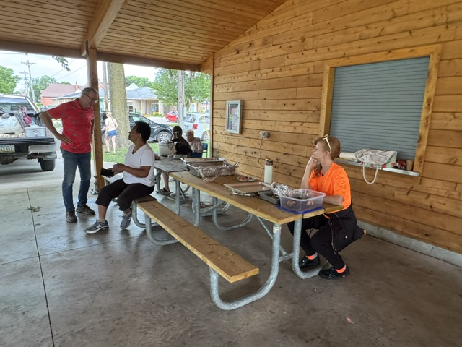
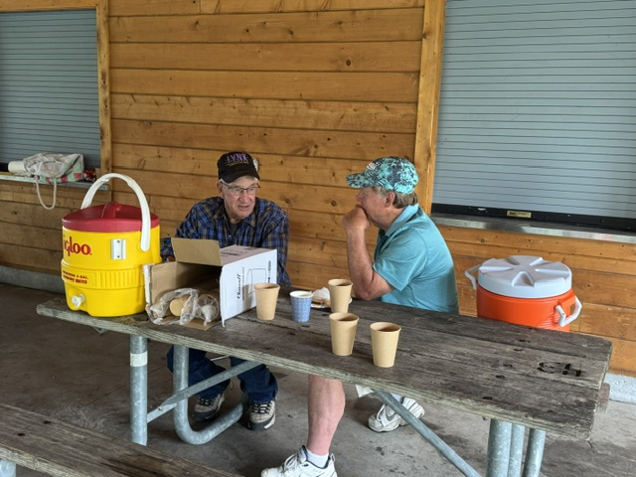

Saturday Service
June 27th was our first Saturday summer worship of 2026! The Worship Board sponsored a potluck picnic following the service. There was plenty of food and good fellowship!
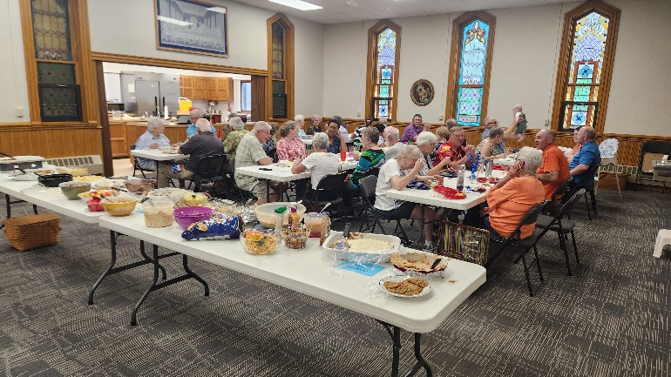
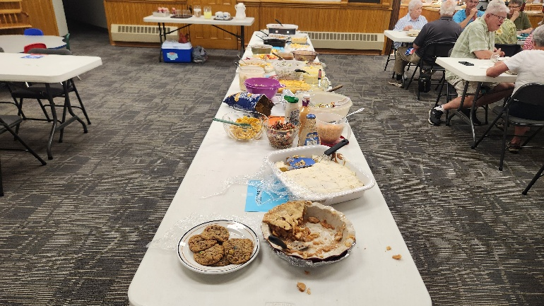

2026 Graduates
Cael Alexander, Hailey Brim, Sherry Leksell
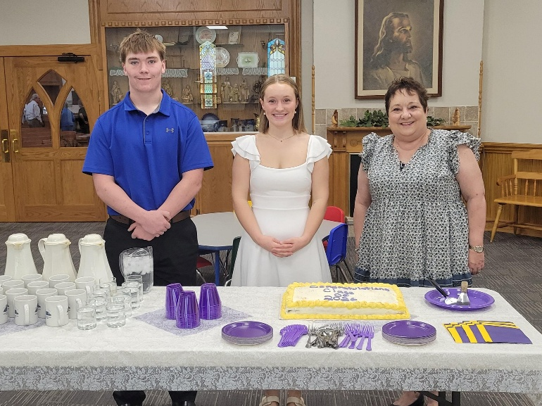

Donations made by Women’s Fellowship
Treasurer’s Report

INCOME May YEAR TO DATE
Pledges and Offerings $25,241.00 $115,427.54
Other Income 0.00 703.09
TOTAL INCOME $25,241.00 $145,802.06
EXPENSES
Outreach and Mission 1,544.00 $6,544.00
Pastoral Services 7,639.46 41,898.47
Maintenance and Repairs 2,613.68 20,360.75
Church Office 3,175.28 16,646.68
Music Ministry 450.00 2,600.00
Christian Education 0.00 0.00
Local Ministry 0.00 0.00
Misc. Expenses 23.18 816.72
TOTAL EXPENSES $15,445.60 $88,866.62

FIRST CONGREGATIONAL UNITED CHURCH OF CHRIST
Webster City, Iowa
Cabinet Meeting held on June 9, 2026
Members Present:
Moderator: Patty Gescheidler Christian Ed: Cindy Henning
Vice Moderator: Dale Olson Trustees: Joyce Gelhaus
Finance Sec.: Dale Olson Women’s Fellowship: Cindy Henning
Treasurer: Tracy Wehrhan Pastor: Craig Blaufuss
Mission: Gayle Olson Worship: Don Bruner
Staff/Parish: Ann Latham Clerk: Stephanie Hill

The meeting was called to order at 7:07pm by Moderator Patty Gescheidler. A prayer was offered by Pastor Craig. The minutes of the May cabinet meeting were read. Gayle Olson moved and Cindy Henning seconded a motion to approve the minutes. Motion carried unanimously. Treasurer’s Report: May offerings exceeded expenses by $10,000.00. Tracy Wehrhan moved and Dale Olson seconded a motion to put the report to audit. The motion passed. Pastor’s Report: Kendy Miller visited our church on May 31st. She answered questions regarding our pastoral search and encouraged us to keep faith in the process. Father’s Day will be celebrated on June 21st. Snack bags will be given out. After the first Saturday service on June 27th, a potluck will be held. Sign-up sheet is in Fellowship Hall. “Salvation” is the topic of adult education over the summer. The Ministerial Association will hold a fundraiser on July 16th at Market Nights. You are encouraged to ‘Find Your Niche’ by signing up (in Fellowship Hall) to fill tasks needed done when Pastor Craig retires. The bus tokens program is in the works. Donations are to be sent to MIDAS in Fort Dodge. Tokens will be sent to VDMC for distribution to partners. Finance: will meet after June 15th to decide on the Scholarship recipients. Mission: The Beacon of Hope meal was delivered and served on June 8th by Andrea Mosbach and others. Forty-two men were served. UCC will serve the Kids Summer Lunch Program on June 15, 17 and 19th. It seems to be well attended. The menu is in the full report. Brownie Sundae will be held this Friday, the 12th from 6:30 – 8:00pm. The sign-up sheets are full!! Mission Board members hosted coffee on May 31st when Kendy Miller visited. Women’s Fellowship: The Funeral Policy is under review by the committee. The Program Book is being worked on. There will be another Thrift Sale this year in September this year, on the 18th and 19th. Worship: A potluck is planned for June 27 after the first Saturday service. Pastor Craig discussed items that need to be done in case of his absence. Two persons should know the ‘One Call Now’ system. The decision about blessing Communion will need to be made. Training on the ear microphone needs done for more than one person. And the protocol for calling off the service needs adjusted. See the full report. Christian Education: A letter was sent out to parents regarding youth programing and the future of KLAB. The response deadline is June 25th. If needed, phoning parents could be done. Adult education is well attended. Staff/Parish: Met on May 31st with one concern which was resolved. Next scheduled meeting is August 30th. Trustees: An agreement was reached to share the cost of repairing 9 concrete squares damaged by heavy lift trucks. The company approved to blow insulation will also hang the louvers and steel siding. Marjorie Groves moved that the Board reports be approved. Stephanie Hill seconded the motion. The motion carried.
NEW BUSINESS: Revision of the Constitution: Discussion ensured over a concern that the Church Constitution be revised for quorums, and the numbers needed for Boards/Committees, etc.. The Constitution was last revised in 2024 and is required to be revised every 5 years. Tracy Wehrhan moved and Anne Latham seconded a motion to NOT form a committee to revise the constitution at this time. The motion carried. Comments on Kendy Miller visit: We discussed the number of churches needing pastors in Iowa. The number may be as high as 27 churches. There are 12 active listings that Pastor Craig found. The number of types of pastoral options presented by Pastor Kendy was new information. ‘Find Your Niche’ project: Some of the groups listed have not been active. The Worship group is up and running. When the ‘Find Your Niche’ Taskforce began, each Taskforce member was to head a specific niche. We asking that the Taskforce members activate their specific niche group. Next meeting is August 11, 2026. Meeting adjourned at 8:25pm.
FULL BOARDS AND COMMITTEE REPORTS:
Pastor’s Report Worship: On May 31 we hosted Rev. Kendy Miller, our Iowa ACM, to preach and answer questions we may have about the search process. Kendy reminded us to remain rooted
in God during this time of uncertainty in our church’s life. She also informed us that there are 27 churches in Iowa seeking pastors, and there is a shortage of clergy to fill those vacancies. Patience and resilience are needed! June 21 is Father’s Day, and Stephanie Hill will sing a solo during the service. Following the service, the Worship Board will give out snack bags to our fathers! Our first Saturday evening service will be held this month on June 27, followed by a potluck picnic in Fellowship Hall. As always, there will be no Sunday Service after our Saturday evening service. On Sunday, July 12, we will offer the sacrament of Baptism to Nolan Fritz as part of our Sunday service.
CE Programming: Adult Ed continues to study “Salvations(s)” over the summer. We are currently studying the different understandings of “salvation” within the Christian tradition. Summer Lunch Program: First Congo will serve meals at West Twin Park for the Summer Lunch program on June 15,17,19 (Mon, Wed, Fri) from 11:30 am-1 pm. The Mission Board will take charge of the meals; volunteers are welcome to help! Brownie Sundae Drive-Thru: will be held Friday, June 12, 6:30-8 pm. The Mission Board is directing this fundraiser. WCMA: will be downtown for the July 16 market nights attempting some sort of fundraiser. We will again hold a Sunday “Faith at the Fair” worship service July 26. Shalom Circle: We continue to meet most Fridays at 6:30 pm in the East Chapel. Find Your Niche Update: There is an updated Find Your Niche signup sheet in Fellowship Hall. The task force is asking everyone to review their selections of how they will serve in the event of a pastoral vacancy, and update what you are ready and willing to do. Also we are asking those who have made no commitments to please consider helping with the anticipated future needs of the church. Community Partners/Bus tokens: We are continuing working on the program, and now have established that donations are to be made out to Midas directly (Mid Iowa Development Association Council of Government,602 1st Ave S, Fort Dodge, IA 50501), and Midas will have a driver drop off tokens at VDMC for distribution to partners in this program. Partners so far are: St. Paul Lutheran and Trinity Lutheran Food Pantries, HC Public Health. Potential partners to be contacted: the Roundhouse, Community and Family Resources, other clinics in town not affiliated with VDMC. The tokens are good for a one-way trip in Webster City only ($2.50). Each provider will need to fill out a quarterly report on token usage. The breakdown of my ministry since May 12 Worship Services led:8 Christian Ed:4 Meetings: 11 Visitation: 7
Mission Board Beacon of Hope—meal scheduled for Monday, June 8th. Meal is prepared, and
Andrea will deliver the meal, and serve at 5pm. —Kids Summer Lunch Program—. June 15, 17, &amp; 19. MWF Menu: Monday 15th-walking tacos, Go Gerts, brownies, and ice cream Wednesday 17th-Hot dogs, Chips, watermelon, and sherbet. Friday 19th-Mac &amp; Cheese, watermelon, ice cream. Kwik Star buns on sale .99, will pick up on the 16th. Andrea will bring cooler, and ice for ice cream and sherbet. Mission board members will meet at church to prepare the lunches. Monday 1030, Wednesday 1000, and Friday 1030. Andrea will come in on those mornings earlier, and start the crockpots. Andrea (Ed) will bring truck to haul what’s needed to the shelter. $202.14 total spent on meals so far, hot dog buns (12 pkg), shredded lettuce (3-16oz bags), and watermelon (7) yet to be purchased —Brownie Sundae. June 12 6:30-8pm. **Sign-up sheets full. Workers to church at 5:30 to set up. Ed and Dale will be our ice cream dippers! Gayle will check for bowls, spoons, and napkins.
—Strengthening the Church - pickle jar raised $280.00 No July meeting Next meeting. Wednesday, August 5. 3pm
Worship Board The Worship Board will not be meeting in June but the Cabinet will - on June 9 at 7 p.m., Fellowship Hall. According to my notes from the Worship Board meeting, Don Bruner has
volunteered to attend the Cabinet meeting, representing Worship Board in my absence. Thanks for doing that, Don! My Chex mix will be in the freezer for Father’s Day distribution to men of the church, along with treats prepared by Gretchen, Jane, and Cindy. Other Cabinet news: The Ministerium will lead an activity for Market Night, July 16. The Trinity Food Pantry will be moving but original plans for the new location have changed. Christian Ed will be discussing the future of Kids Learning About the Bible (KLAB). The Trustees are concerned about damage to the sidewalk caused by big equipment used on the bell tower/bat exclusion. Trustees also will look into progress on insulation needs. The Northwestern Association of the Iowa Conference is donating $1,000 to Pilgrim Heights/Our Sacred Space and the amount of a CD (maturing in January 2027) around $7,777 to the Iowa Conference UCC. The NW Association Annual Meeting will be held in Hartley in April 2027. Wil Groves and Patty Gescheidler will set out a new Niche List with an updated set of headings, inviting the congregation to sign up again or anew. It’s been a couple of years since we all signed up on the first list and life has changed for many, so a new list of volunteer needs will be offered. Michele will have information in the June newsletter. Here are the details: Niche Group Update: review and renew. When the Task Force formed Niche Groups in 2024, we asked volunteers to make a one-year commitment to one of the five “niche groups” we created. That year has become two. Much has been accomplished and we thank all who have contributed their efforts to make it so. But we need to keep these groups active as we move forward in our pastoral search. The Task Force now asks that you “review and renew” that commitment. This is also a plea to those who were not part of the niche group to join us now. Here is a list of the Niche groups and the responsibilities of each. Prayerfully consider adding your name to one or more of the groups that fit your interests and abilities. Need at least 4, working closely with the worship board.
Trustees Agenda: Sidewalk damage caused by the lift used by Orkin. Agreement was reached to split the repair cost of 9 squares. Vesey, Orkin and UCC will share the cost. The work will be done by
Goodell Concrete. This will be completed after the bell tower and insulation are complete. Integrity Spray Foam and Construction cellulose insulation will be blown in attic. Cost is $13,865. Final bill for Jim Vesey has been approved at $10,000. Integrity Spray Foam and Construction will be installing bell tower louvers which have been ordered, hang steel that Peterson Construction bought, J trim and caulk cost $2,050. Lift fee $750. Total of work $2,800. All costs related to above have been tentatively approved by board members.

FIRST CONGREGATIONAL UNITED CHURCH OF CHRIST

Address Service Requested

God is still speaking
to everyone in the home of:



